

**TABLE OF CONTENT**

**ACKNOWLEDGEMENT** **5**

**SYNOPSIS** **6**

**PROBLEM DEFINITION** **7**

**CUSTOMER REQUIREMENT SPECIFICATION (CRS)** **8**

**SCOPE OF THE WORK (IN BRIEF)** **9**



eProject: Arts

ARTS

| Faculty. | Muhammad Shaoib | |
| --- | --- | --- |
| Batch. | PR2-202202F | |
| Serial No. | Enrollment Number | Student Name |
| 1. | 1365589 | Malik Arshan |

eProject: Arts

2

# ACKNOWLEDGEMENT

* First, we would like to express my special thanks to my teacher Muhammad Shoaih , who helped us a lot in finalizing this project within the limited time frame, valuable counseling and assistance for the accomplishment of this project.
* Secondly we would also like to thank the eProject team at Aptech Head Office, who gave us the golden opportunity to do this wonderful project about Aura Watch.
* Thirdly, we also thank the eProject team, some of the benefits are as under:
  + Re-enforcement of skills happens in the experiential learning process.
  + A mentor, ensuring that we do not get drifted, constantly guides us.
* It gives us a lot of confidence to face an interview as we have worked on a project. We can explain virtually everything on the subject we have learnt.

eProject: : Arts

3

# SYNOPSIS

**Introduction** :

Arts is a stationary shop that sells arts, gift articles, greeting cards, dolls, files, hand bags, wallets, and as well some of the beauty products, etc…. As there is a lot of demand for the greeting cards, gift articles, hand bags, etc…. and in this busy world where one can hardly find time to go out for shopping and with the emerging new technologies where one can purchase products by placing an order through online by sitting at home/office either by credit cards or by VPP or through Cheque or through DD

**Existing Scenario** :

Our client is a retail dealer of various products like gift articles, dolls, files, etc…. The customers usually visit the shop in order to purchase the products. He has a huge variety of products at his shop. Also as there is an increase in the demand of these products and as well as there is a huge variety of combinations and products available, and as the number of retail dealers are increasing day by day, it has become difficult to withhold in the market and as well to retain the customers.

Also as they don’t keep track of the products, it is hard to find how many products are available in the shop.

eProject: : Arts

4

# PROBLEM DEFINITION

**Proposed Solution** :

In order to cope up in this competitive world, and to retain the customers, to automate the process, our client wants an application to be built meeting the current technology trend where the customers can place their order through online by sitting at their office/home, and providing the products as per the orders received by the dealer at the door steps of the customer.

He says that he wants the application to hold the details of the products in detail like price, description of the product and each product is allocated with a unique 7 digit product id which includes 2 digit product code and 5 digit product number. Also he says that for fetching the details of the products, the customer need not be the registered one, but for placing an order one has to be the registered user of the site.

After placing an order, the dealer would dispatch the order as per the type of delivery that the customer has chosen. He says that the application should generate a unique 16 digit order number (includes the type of the delivery (1 digit) that the user has opted for, Product id (7 digit), and the order number (8 digit)) as soon as the order is placed by the customer.

For the order which is placed through the credit card payment or through cheque, the payment should be cleared first and then only the product will be dispatched to the customer’s premises. Also he has provided an option like if the customer is not satisfied by the product then the customer can either replace it (new product will not be sent) or he can return it back within a week's time, so that he can get back his money which he has paid for that product. Also the warranty card will also be provided for the products which have some warranty.

The dealer alone should be able to update the details of the employees, products and their details, and he can check the orders that are received based on the date, order type (delivery) and he alone has the right to create an employee profile like username or login id and the password. The employee should only be able to change his password, and he can check the details of the orders so that the products can be dispatched as per the customer’s request and that they can be delivered in time.

Also he says that there should be an option on the web site where the customer can send their feedback regarding the services that they attain from them.

eProject: : Arts

5

# CUSTOMER REQUIREMENT SPECIFICATION (CRS)

The Web site is to be created based on the following requirements.

► **Non-Financial** :

• The dealer alone can manage the details of the products, employees and as well he can check the details of the orders, stock details, feedbacks and FAQ’s from the customers.

• The employee will only be able to change his/her password, and check and update the details of the orders and the delivery reports

• The details of the products, employees, orders, delivery/dispatching details and as well that of the customers, are needed to be maintained using the help of the database.

• Also the customer should be able to check the details of the order that he/she has placed.

• An advanced search option so as to fetch the details with ease is to be implemented.

• The registered customers should alone be able to manage his/her account, orders placed by them and can check the details of the products while the non registered customers can only be able to check or fetch the details of the products and register with the site

• The application should be automated, so that the details like the number of products that are available with them, dispatched details like when the product has been dispatched, the payment details, and the delivery details can be attained at an ease.

• The details of the payments at the time of placing an order should be captured in details based on the type of payment/dispatch that the customer is willing to have like the detailed description of the payments (credit card details if the payment is through the credit card, and cheque details if the payment is through cheque.

• The customer can only be able to cancel the order provided that the product is not dispatched from the dealer’s premises.

► **Financial** :

• For the customers who have placed an order for which the payment type is either through cheque or through credit card, only after the clearance of the payment the products will be dispatched.

• If the order placed is through VPP, the customer is needed to make the payment at the time of delivery at their premises.

• If the customer is not satisfied with the product then he can either place a request for replacing the product or he can return the product, so that he/she can get the payment back, provided the product is returned with in the week days time from the time of the delivery of the product at the customer’s premises.

**Functional Requirements** :

• Maintaining the details of the Employees, product details, stock details, order, and delivery details of the products and that of the customers are to be maintained with the help of the database.

• There should be separate login for Admin, Employees and for the customer.

eProject: : Arts

6

# SCOPE OF THE WORK (IN BRIEF)

* **Technologies :**

The website is to be developed for the Windows Platform using HTML5, CSS, Bootstrap, JavaScript,

MYSQL , Jquery , Sweet Alert and Php Version 8.1.10 . The site should work well in all leading browsers

including Chrome, IE, Firefox etc..

Homepage shows Latest products From database of different categories, big sale, collection, new Greeting Cards... Every content is direct to relative content. Home page also has links to all other pages which are allowed to be used by User and if Admin Logs in it also has a link to Dashboard at top right of navbar .There are also links for tracking page where user can track its product by tracking id and there is also a link to the page of order history. .

eProject: : Arts

7

DFD’s

Admin DFD’s :

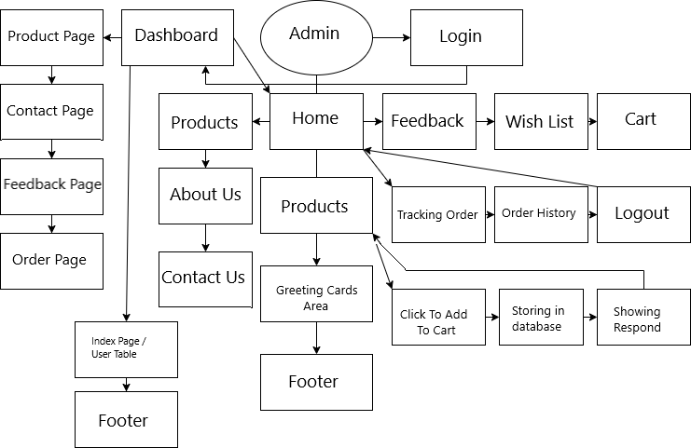

eProject: : Arts

8

DFD’s

Employee DFD’s :

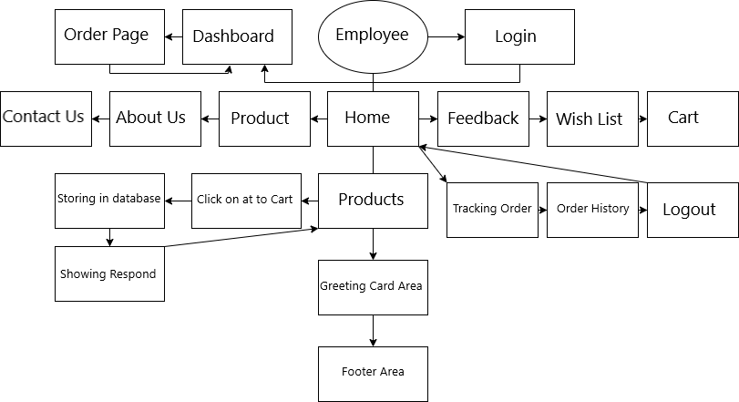

eProject: : Arts

9

DFD’s

User DFD’s :

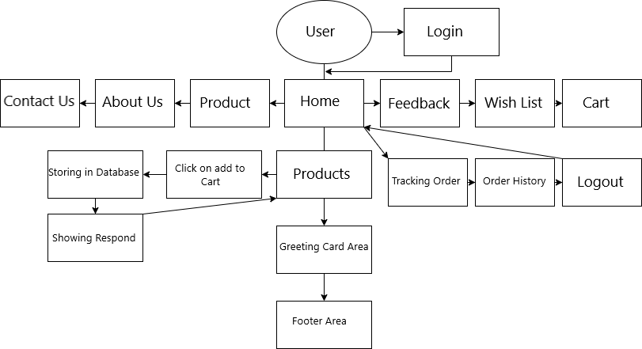

eProject: : Arts

10

FLOW CHART

Signup Flow chart :

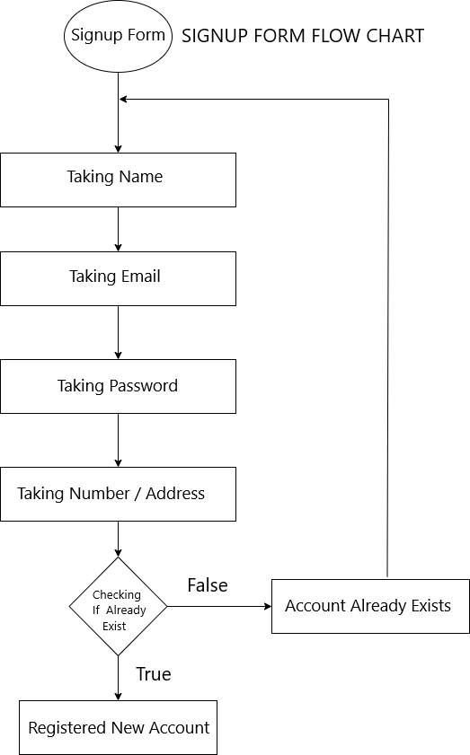

FLOW CHART

Login Flow Chart :

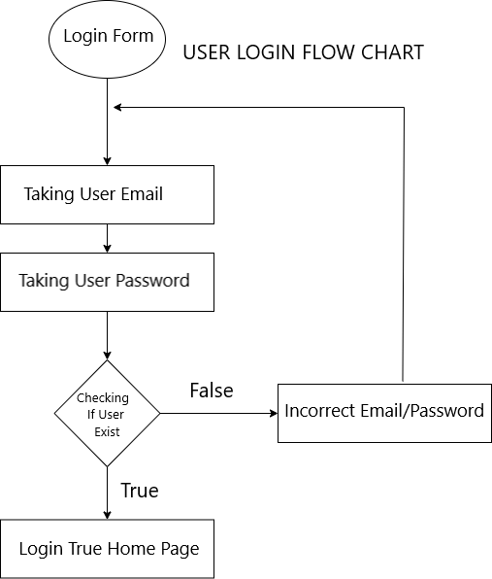

eProject: : Arts

12

FLOW CHART

Forgot Password Flow Chart :

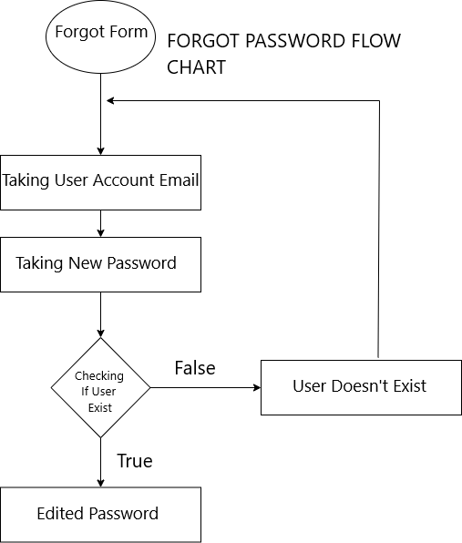

eProject: : Arts

13

FLOW CHART

Wish List Flow Chart :

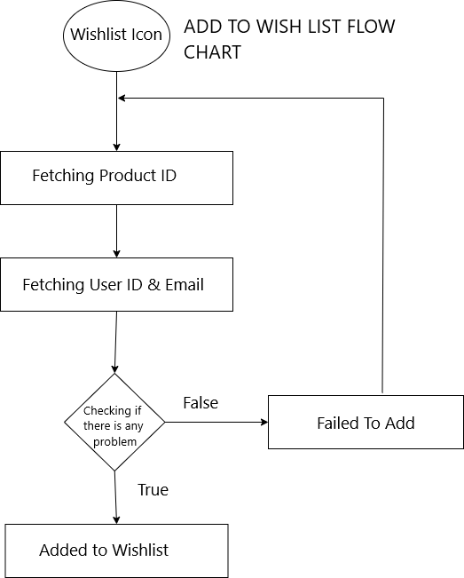

eProject: : Arts

14

Add To Cart Flow Chart :

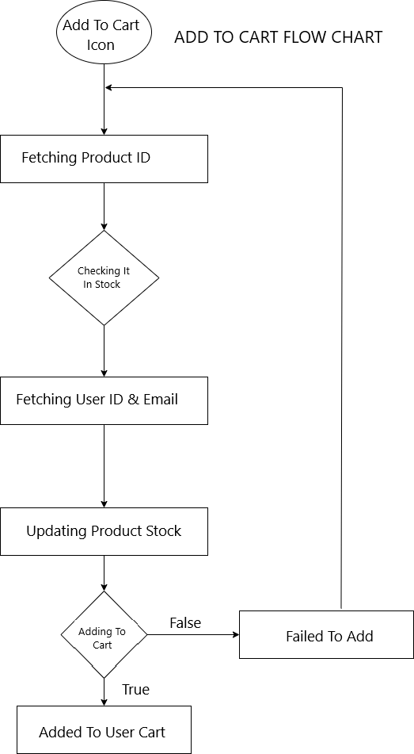

FLOW CHART

Ban User Flow Chart :

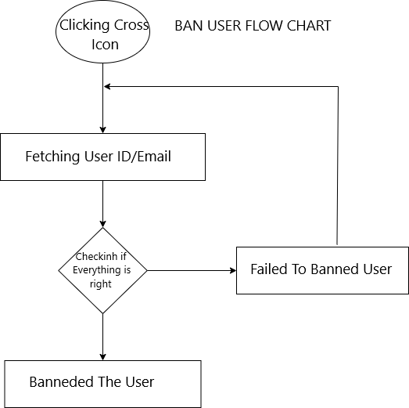

eProject: : Arts

16

FLOW CHART

Contact Flow Chart :

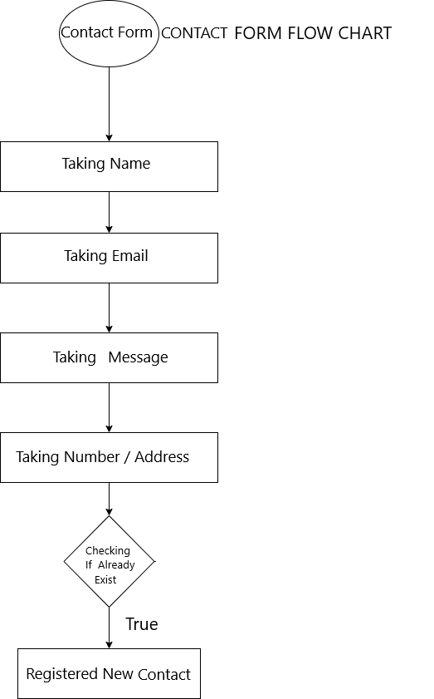

eProject: : Arts

17

FLOW CHART

Feedback Flow Chart :

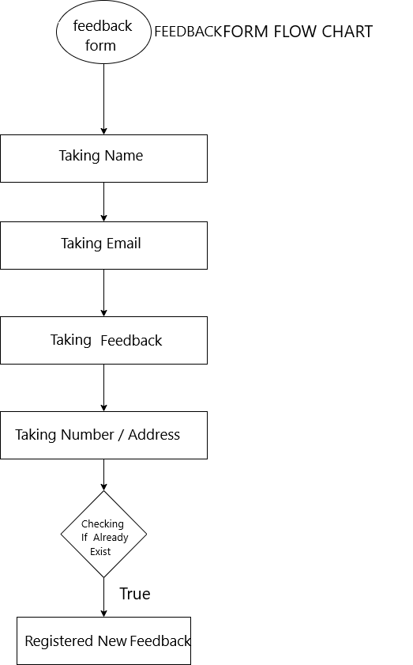

eProject: : Arts

18

FLOW CHART

Order Flow Chart :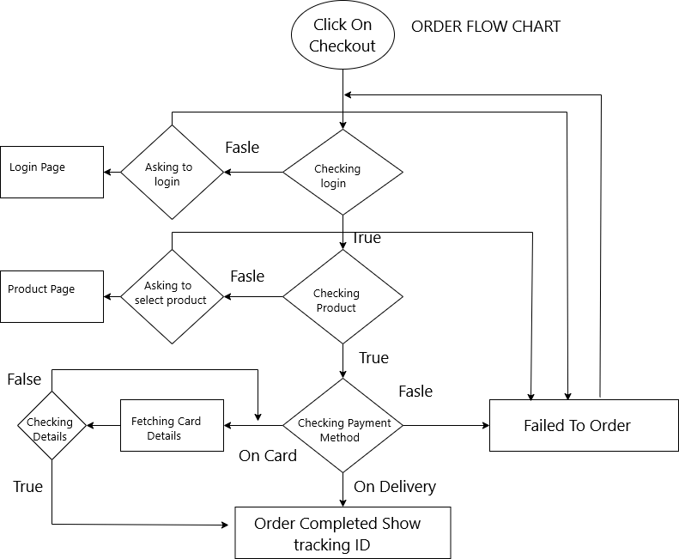

eProject: : Arts

19

PROCESS DIAGRAM

Login Process Diagram :

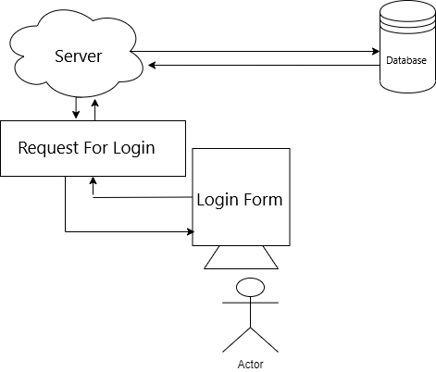

eProject: : Arts

20

PROCESS DIAGRAM

Signup Process Diagram :

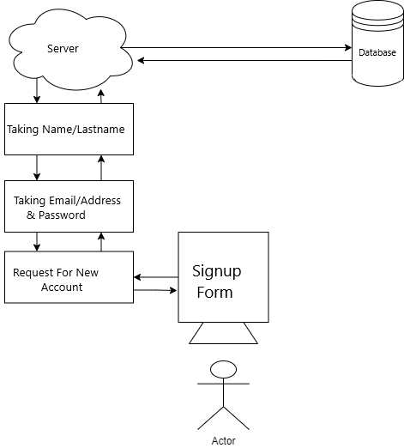

eProject: : Arts

21

PROCESS DIAGRAM

Forgot Password Process Diagram :

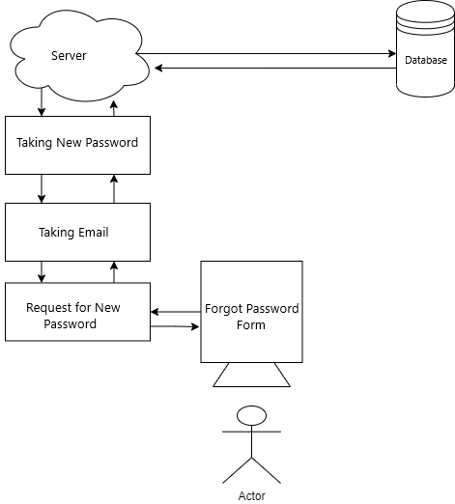

eProject: : Arts

22

Database Design / Structure

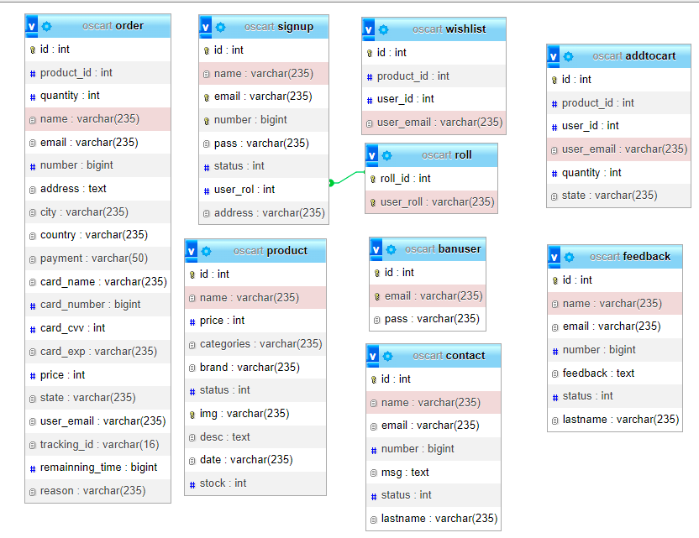

eProject: : Arts

23

HTML PAGE

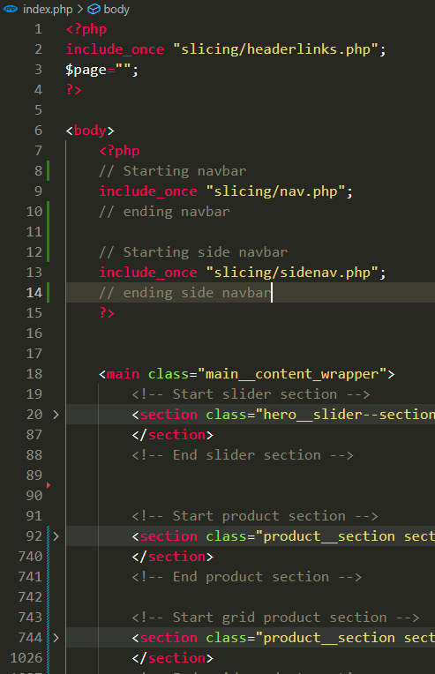

eProject: : Arts

24

PRODUCT HTML

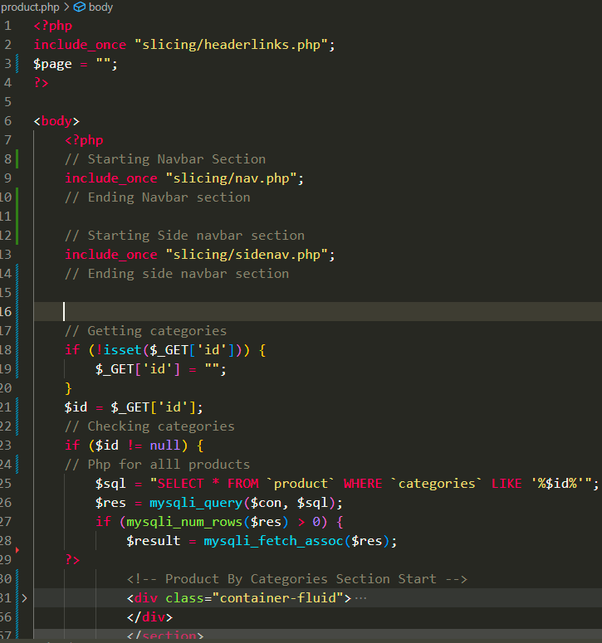

eProject: : Arts

25

PRODUCT DETAIL HTML

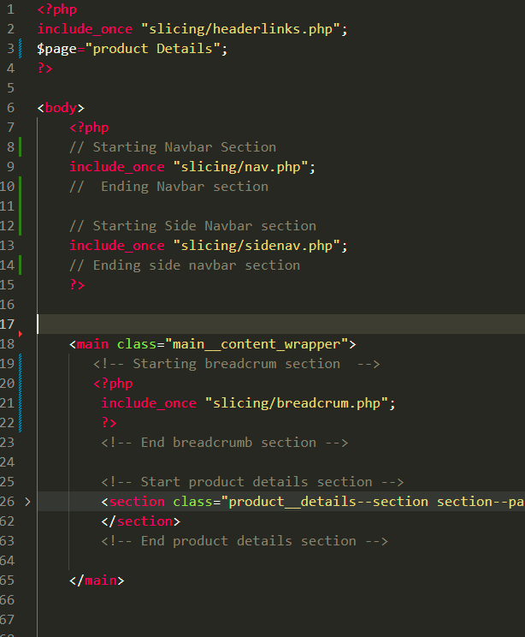

eProject: : Arts

26

ABOUT US HTML

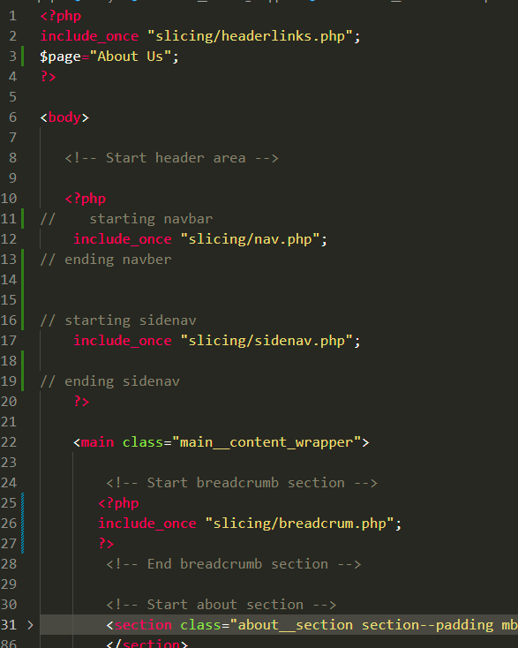

eProject: : Arts

27

CONTACT US HTML

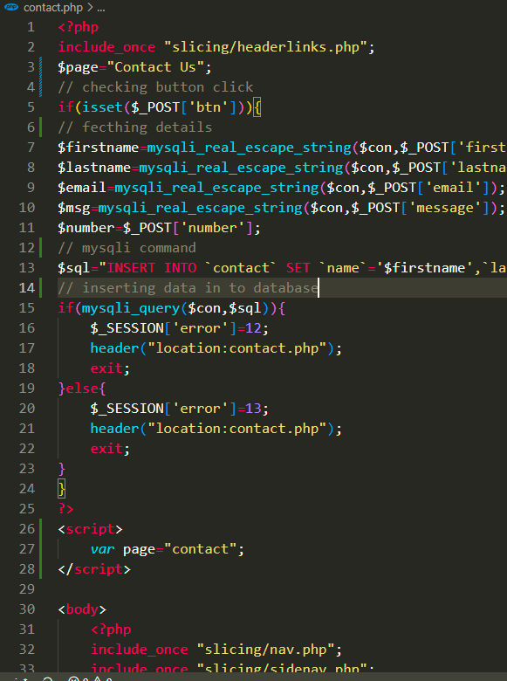

eProject: : Arts

28

FEEDBACK HTML

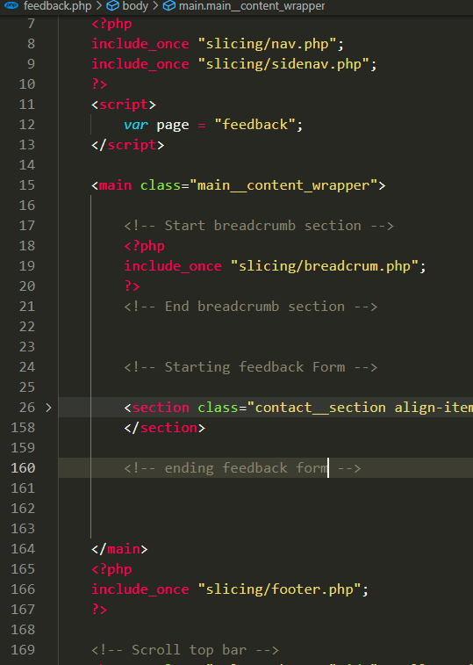

eProject: : Arts

29

LOGIN HTML

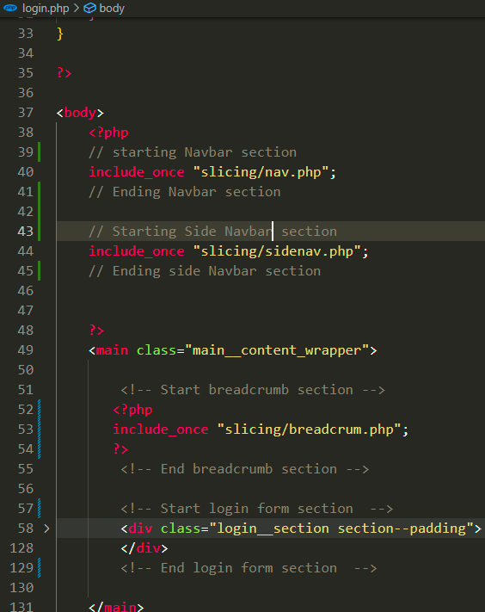

eProject: : Arts

30

SIGNUP HTML

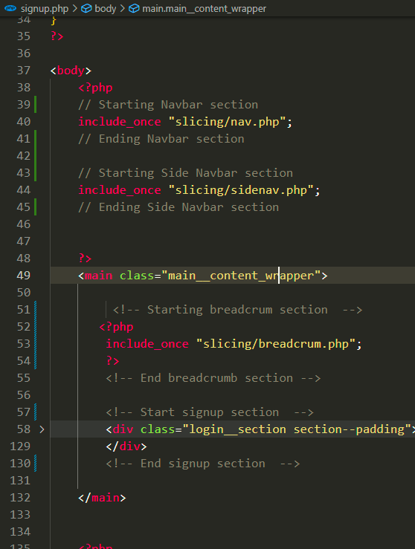

eProject: : Arts

31

FORGOT PASSWORD HTML

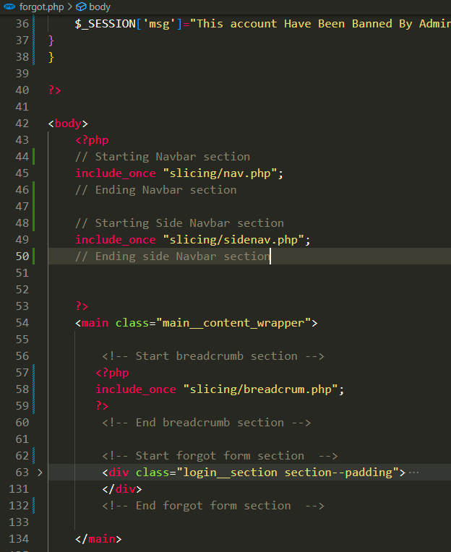

eProject: : Arts

32

SEARCH HTML

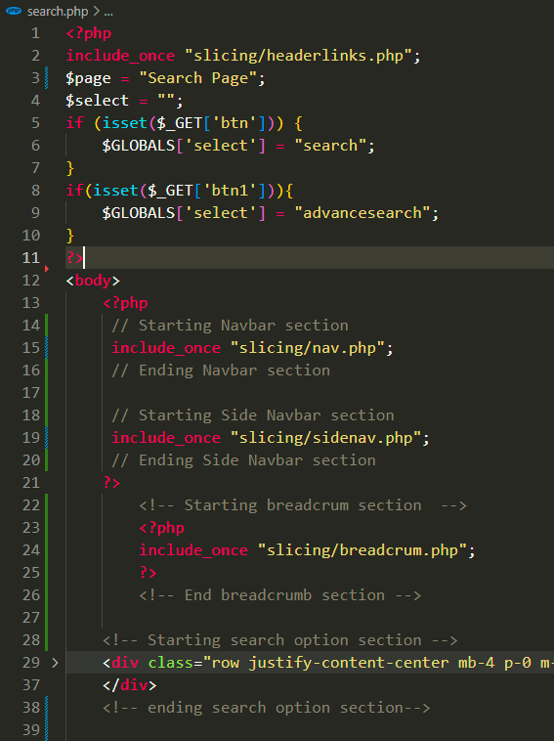

eProject: : Arts

33

WISH LIST HTML

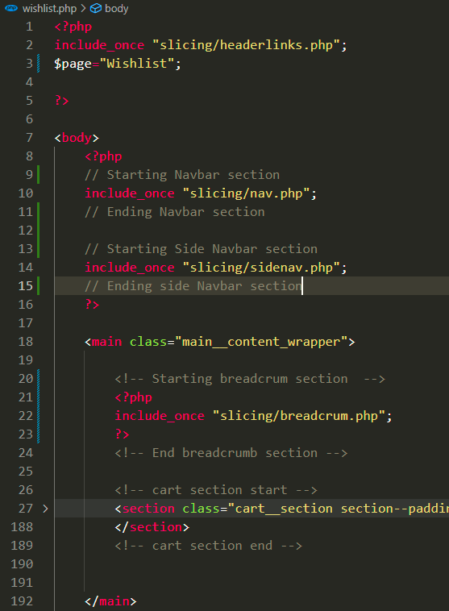

eProject: : Arts

34

CART HTML

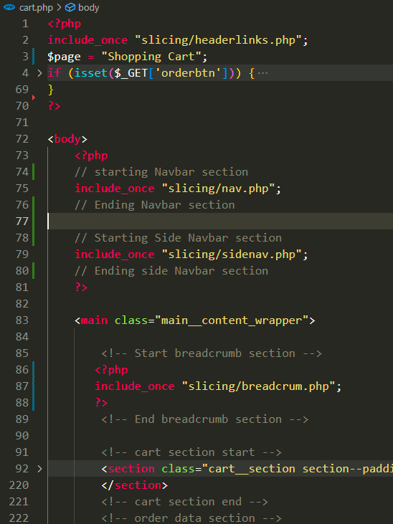

eProject: : Arts

35

# C:\Users\Malik Aqeel Ahmed\AppData\Local\Microsoft\Windows\Temporary Internet Files\Content.Word\Screenshot (13).png

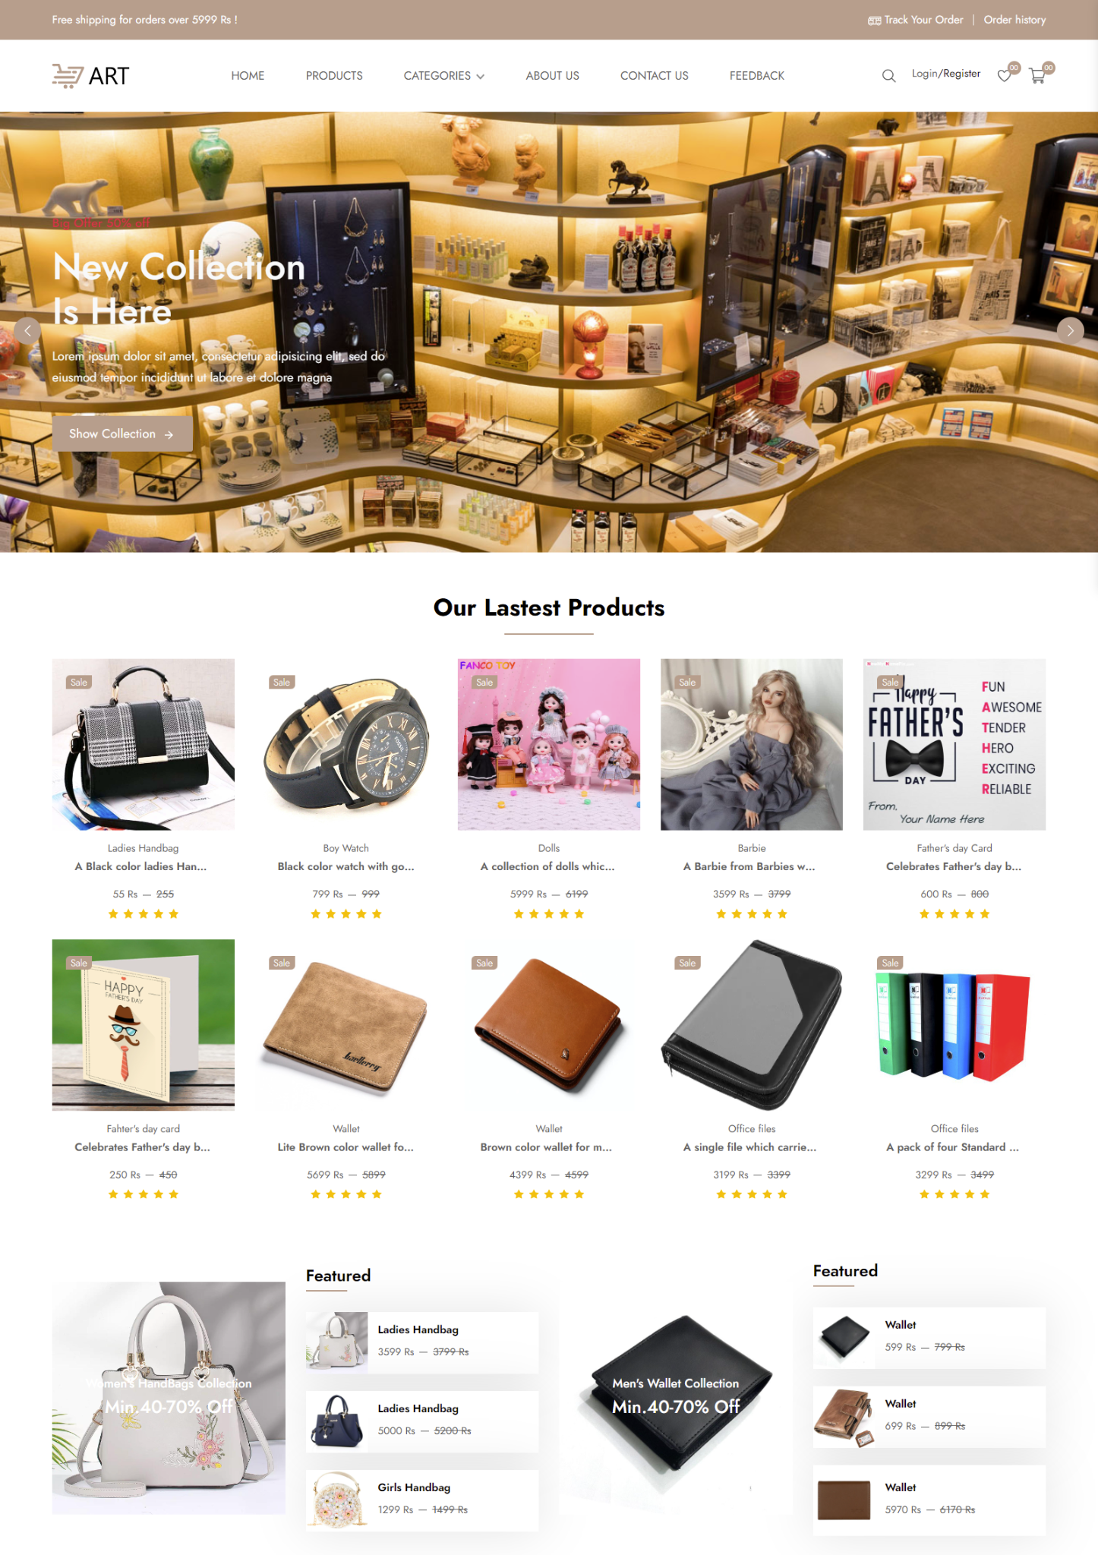

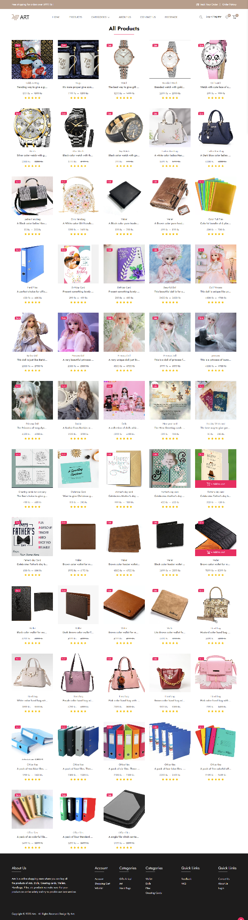

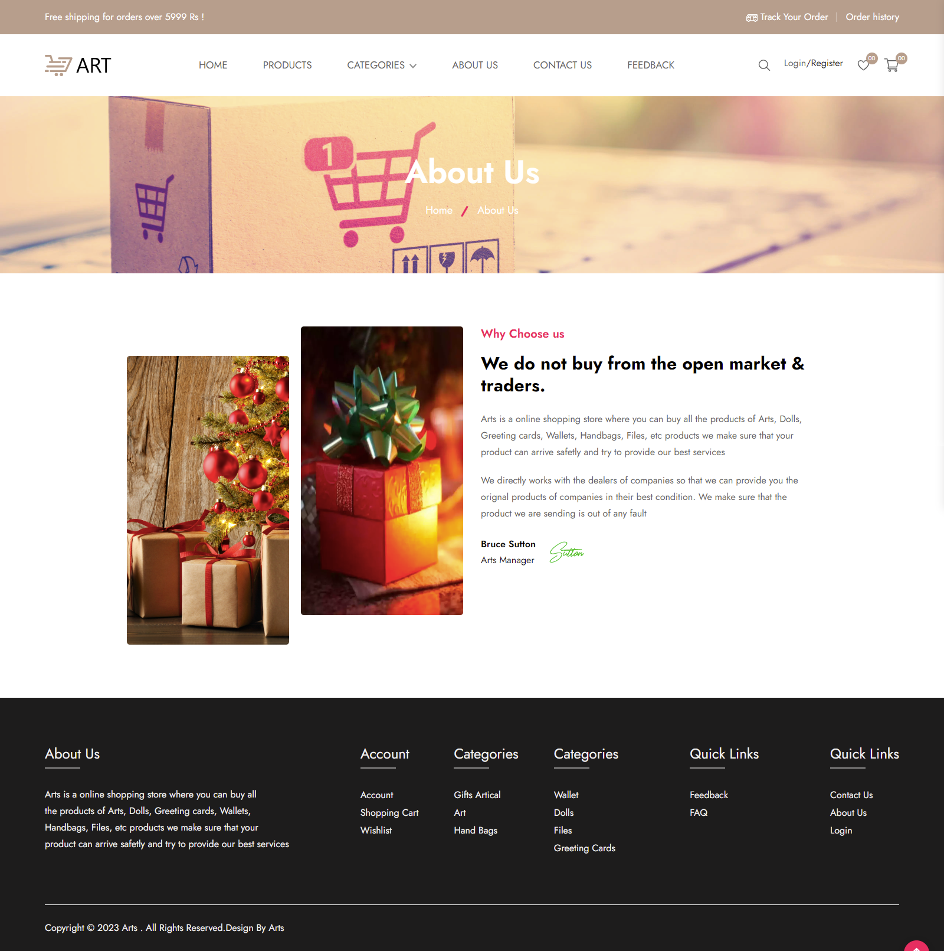

eProject: : Arts

39

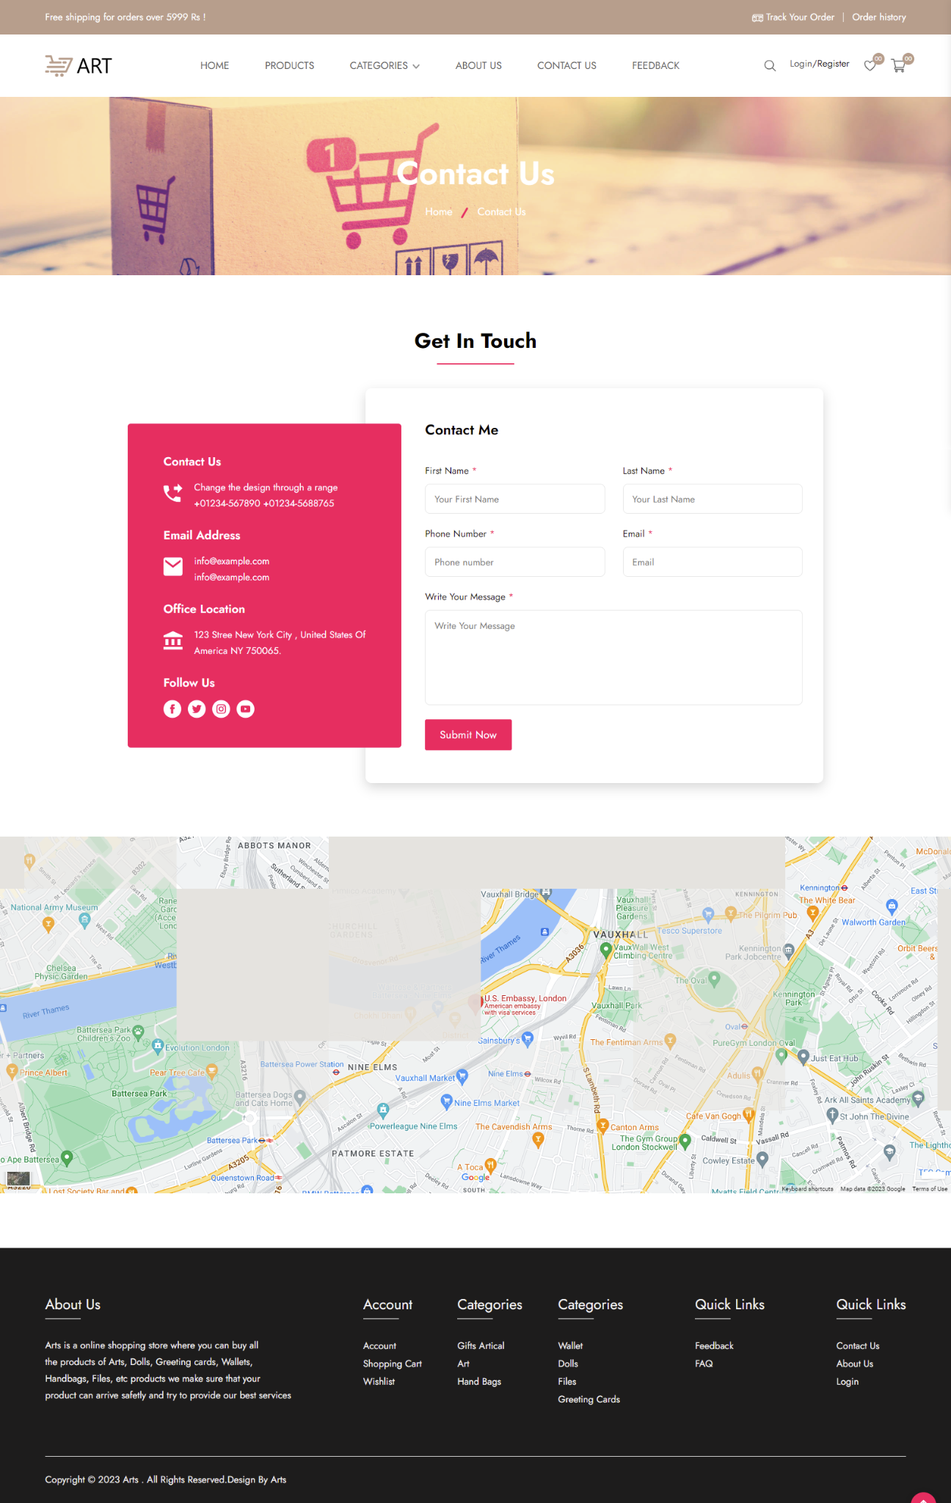

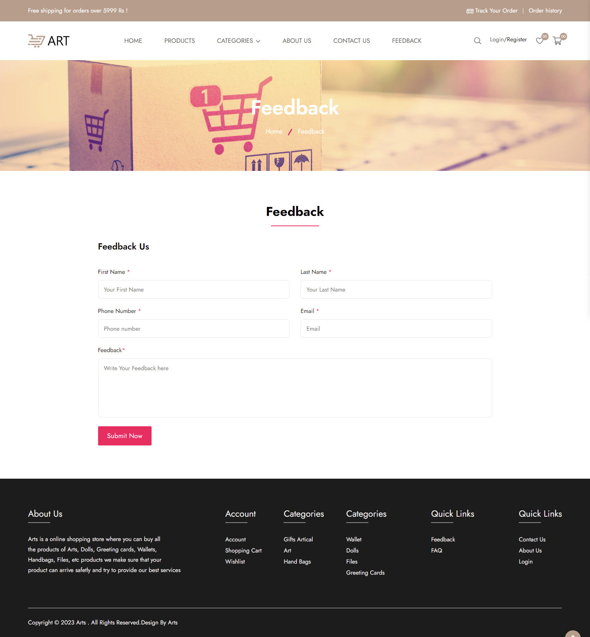

eProject: : Arts

41

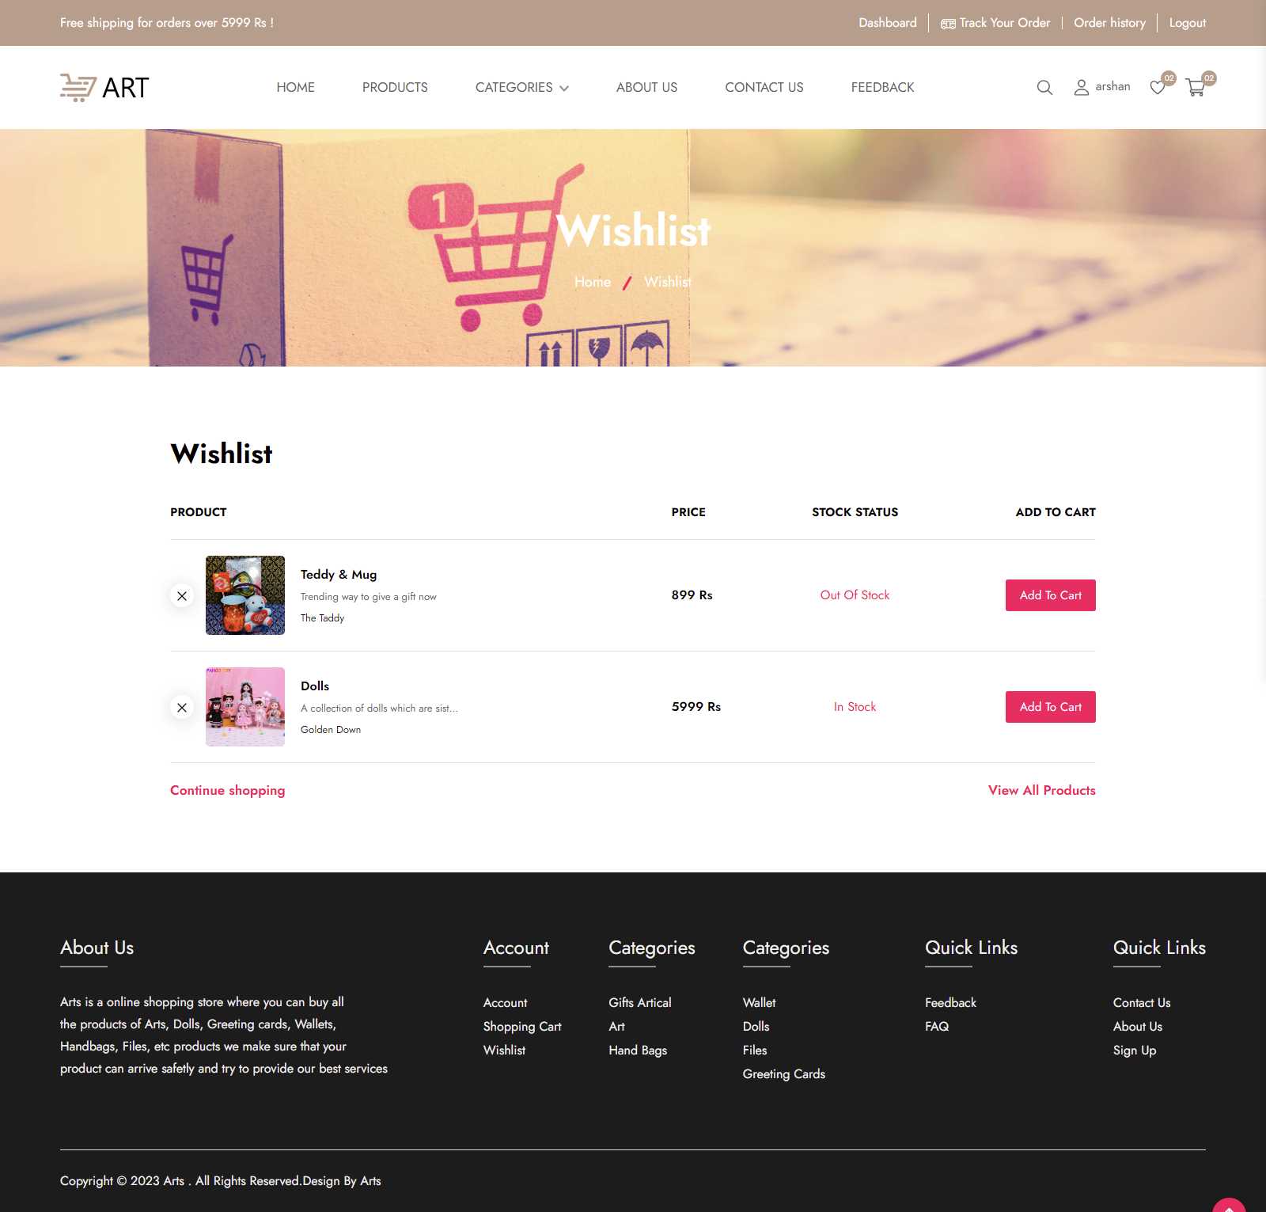

eProject: : Arts

42

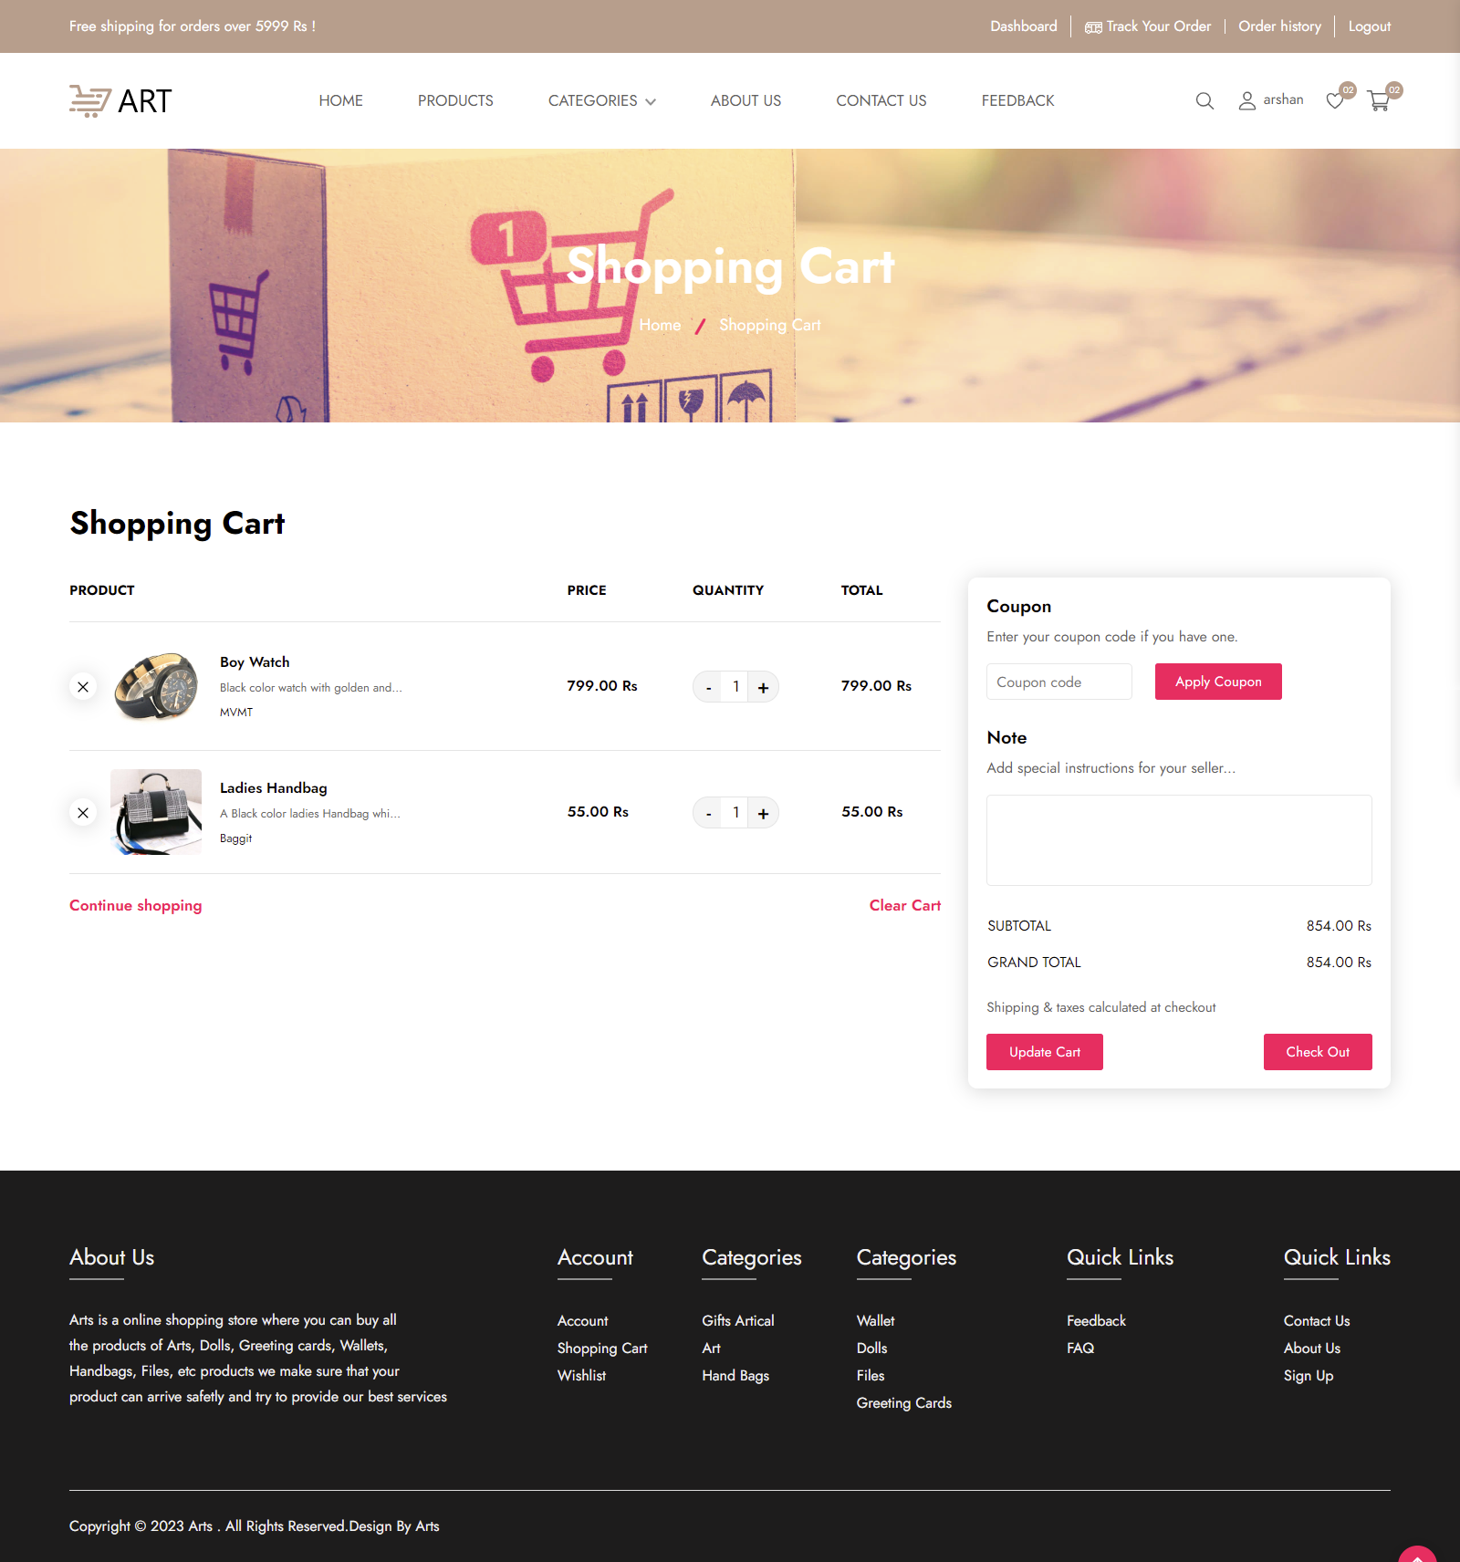

eProject: : Arts

43

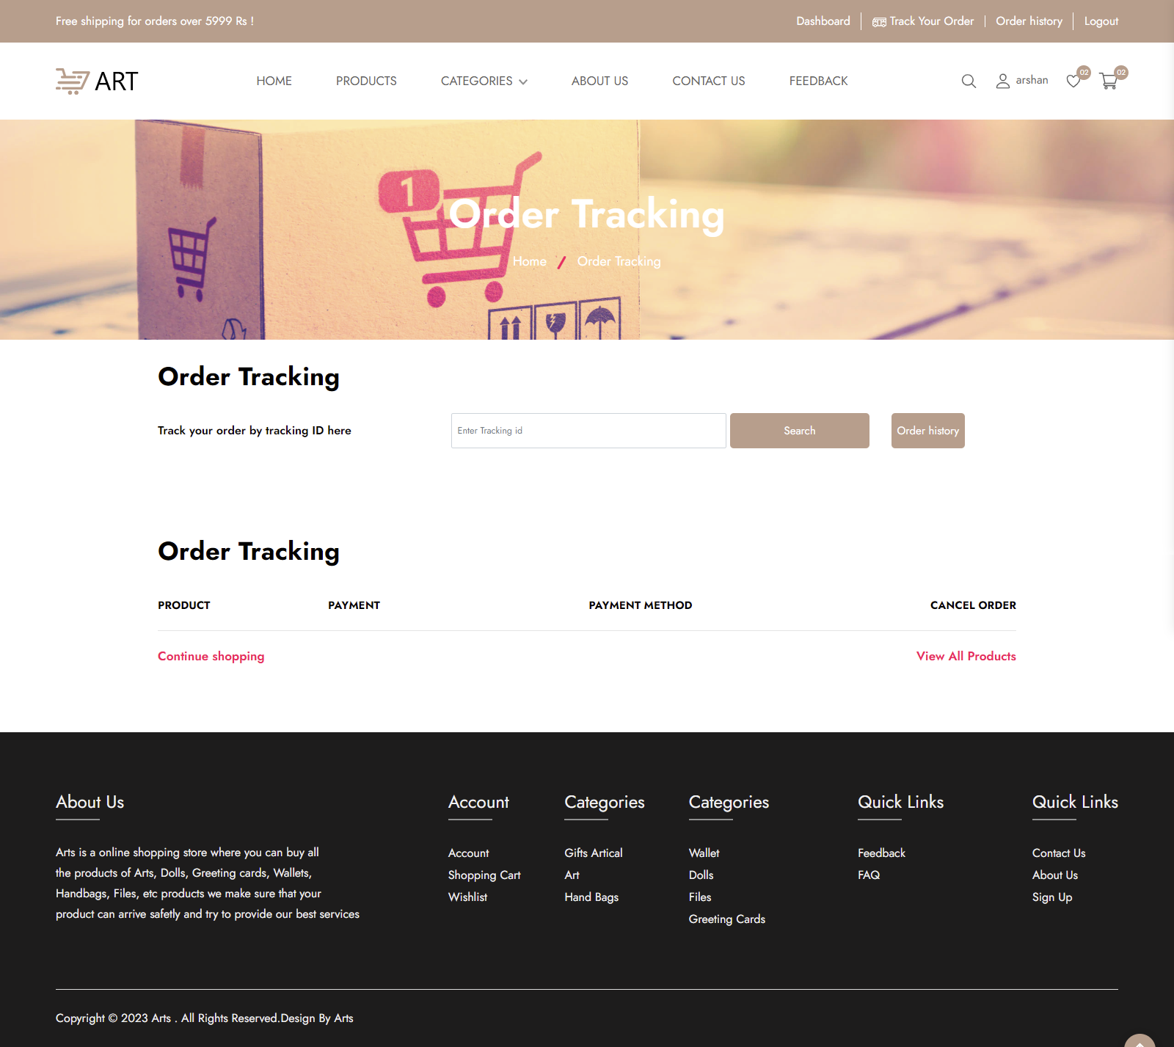

eProject: : Arts

44

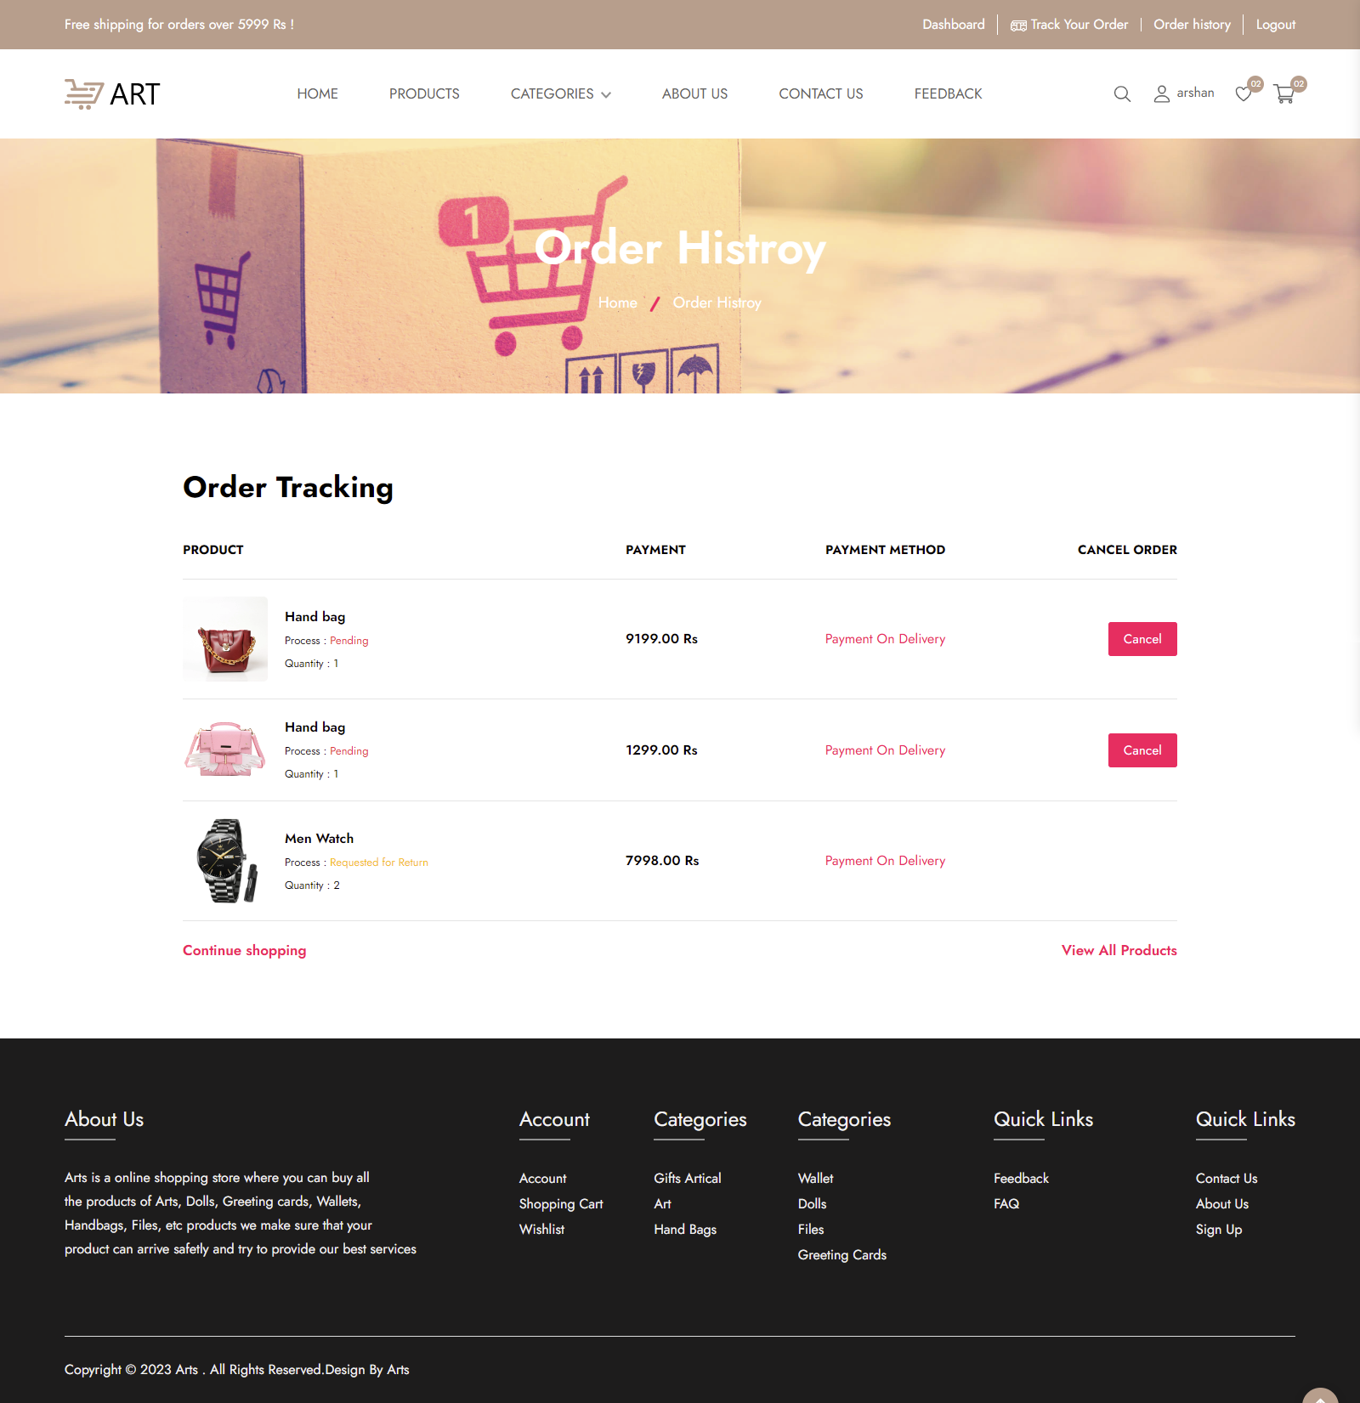

eProject: : Arts

45

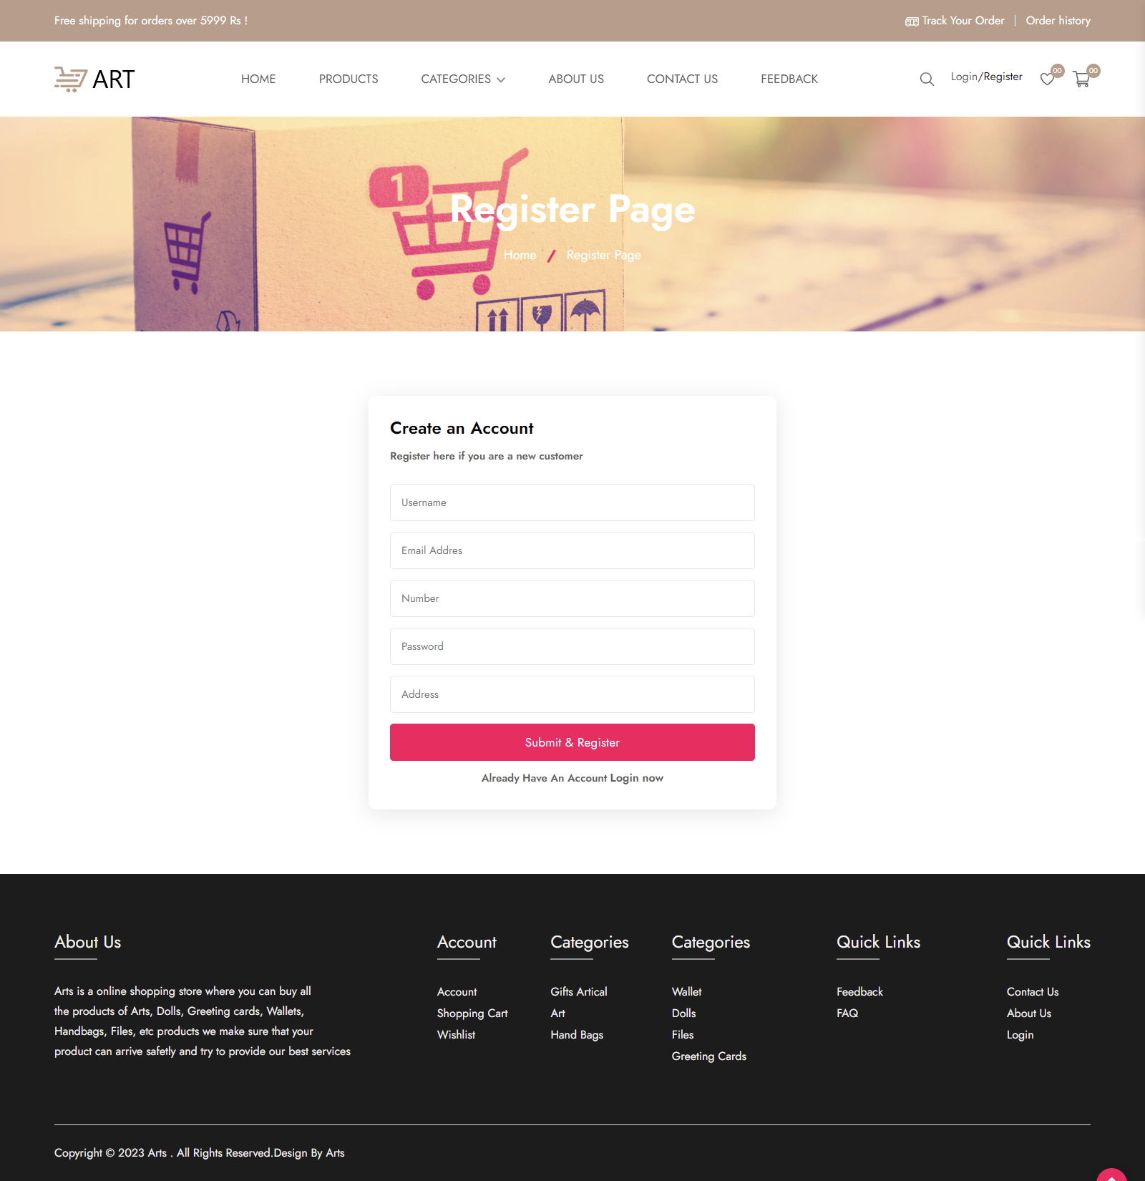

eProject: : Arts

46

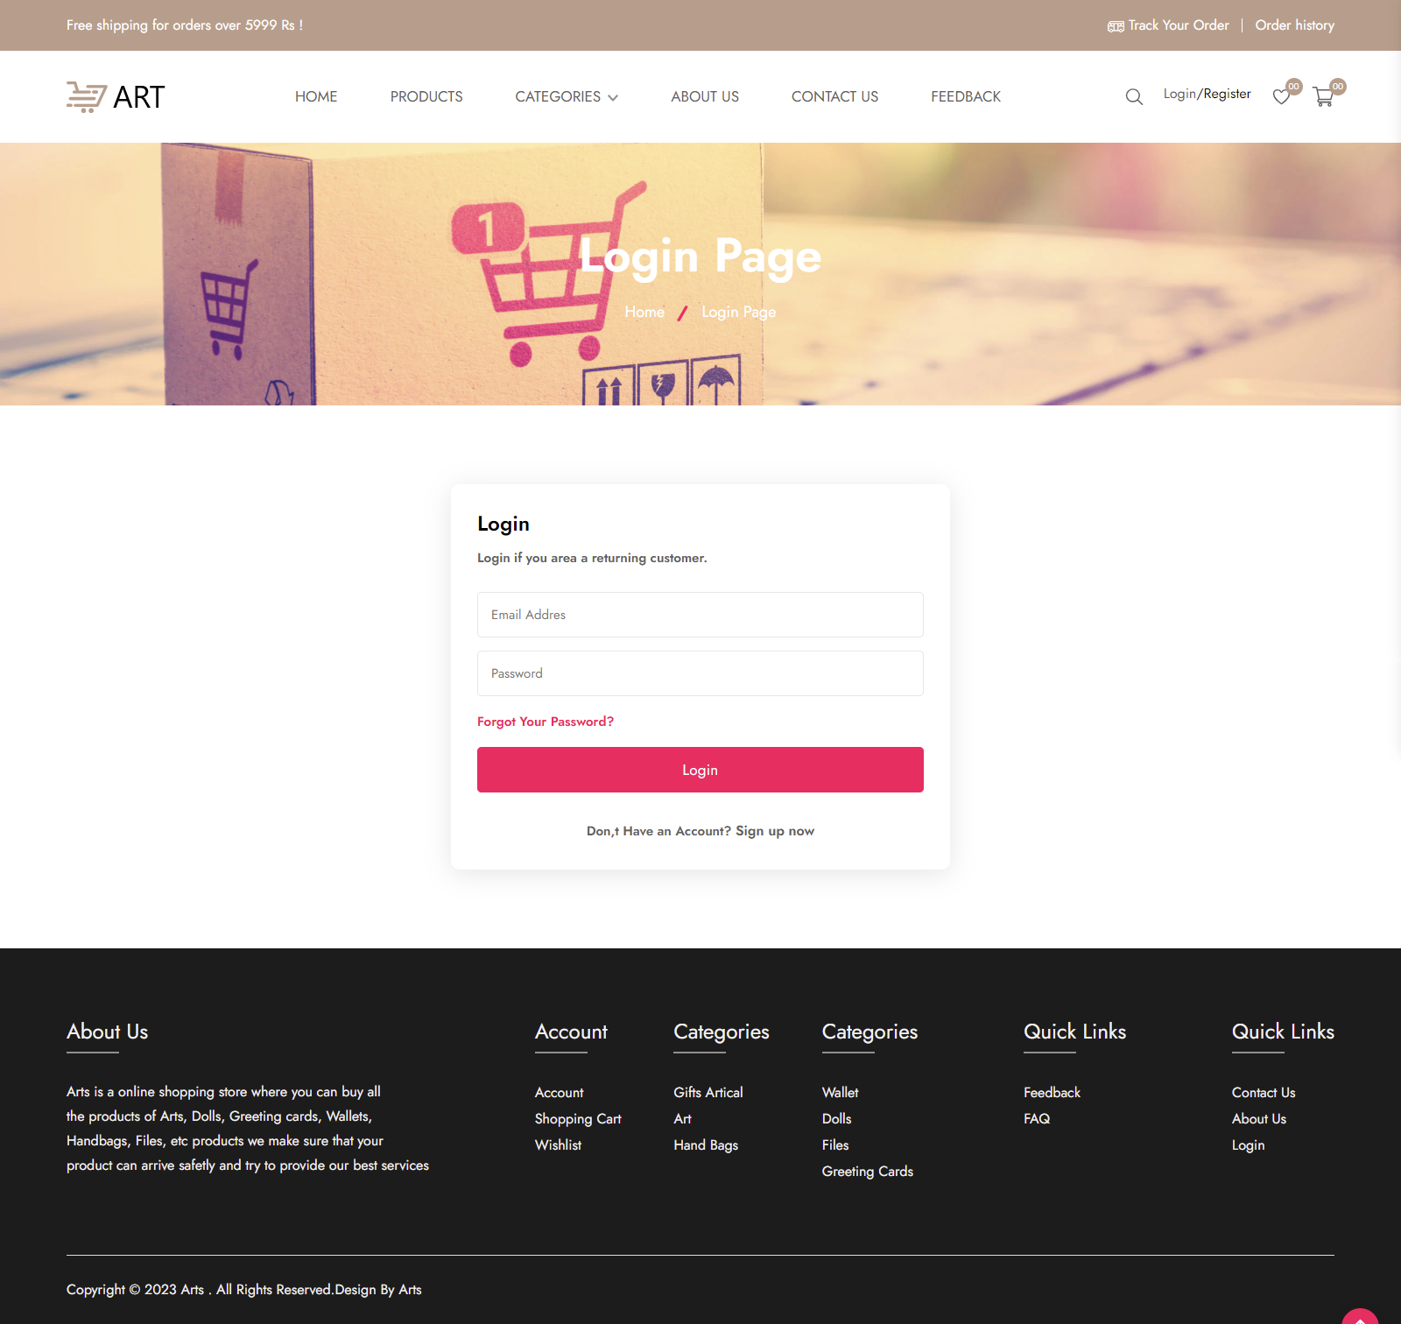

eProject: : Arts

47

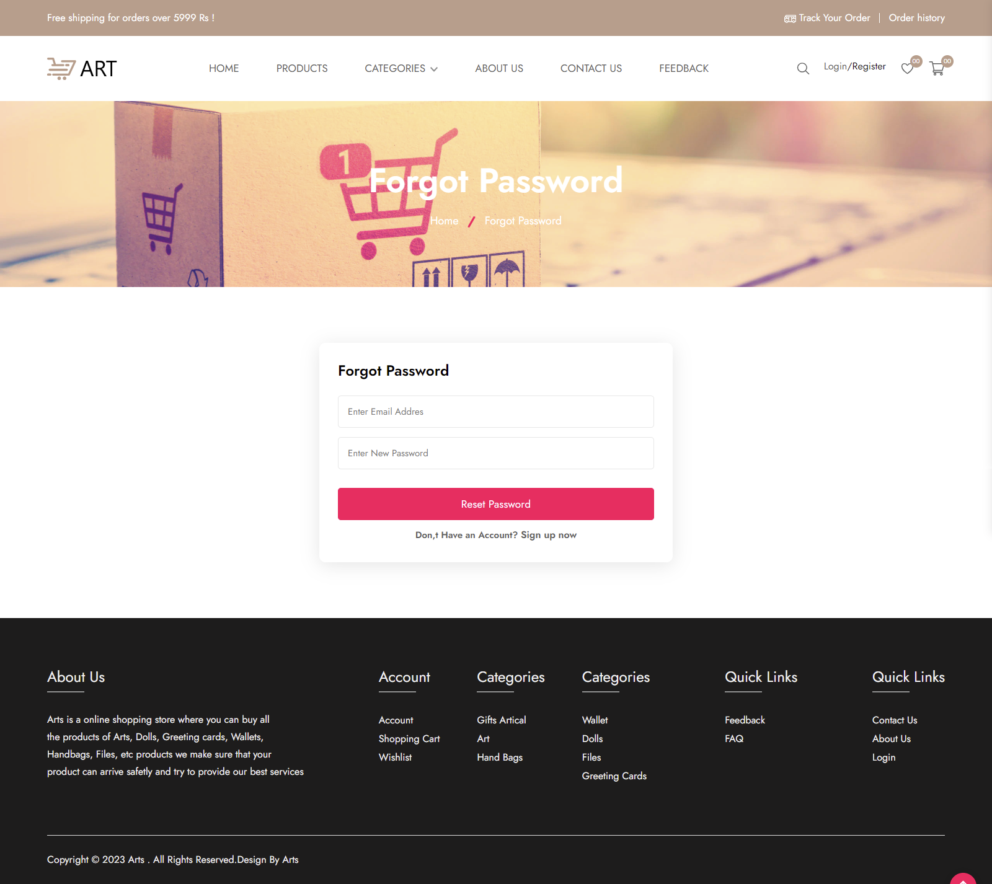

eProject: : Arts

48

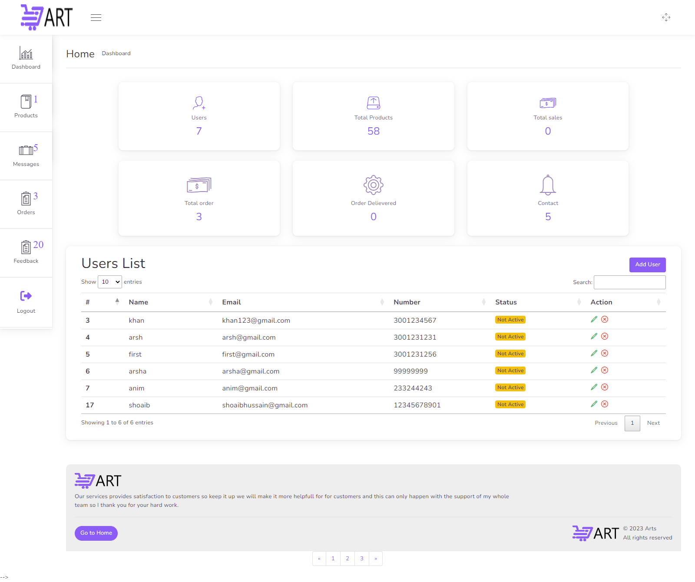

eProject: : Arts

49

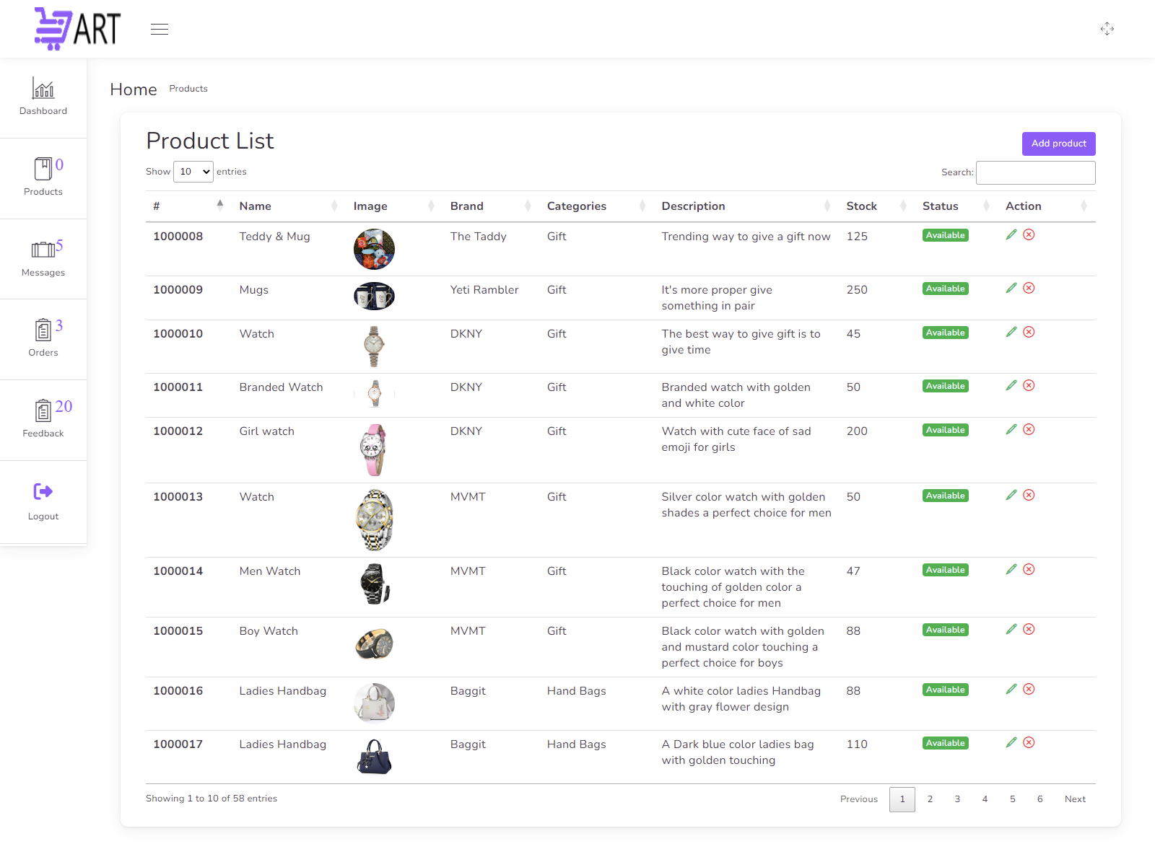

eProject: : Arts

50

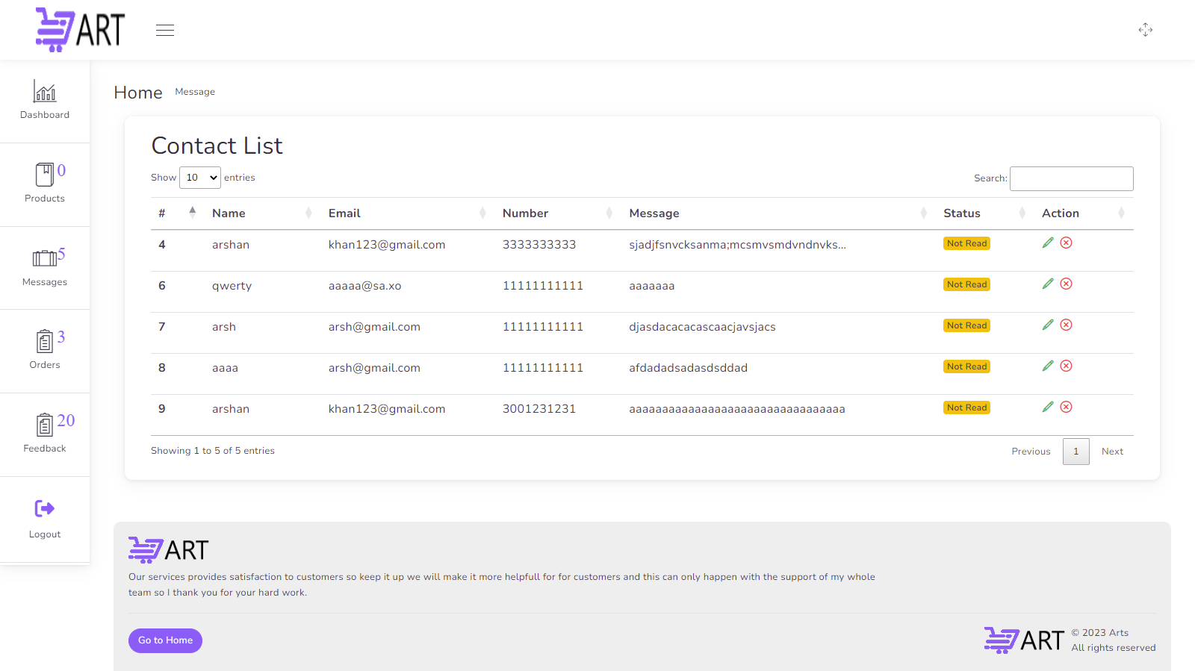

eProject: : Arts

51

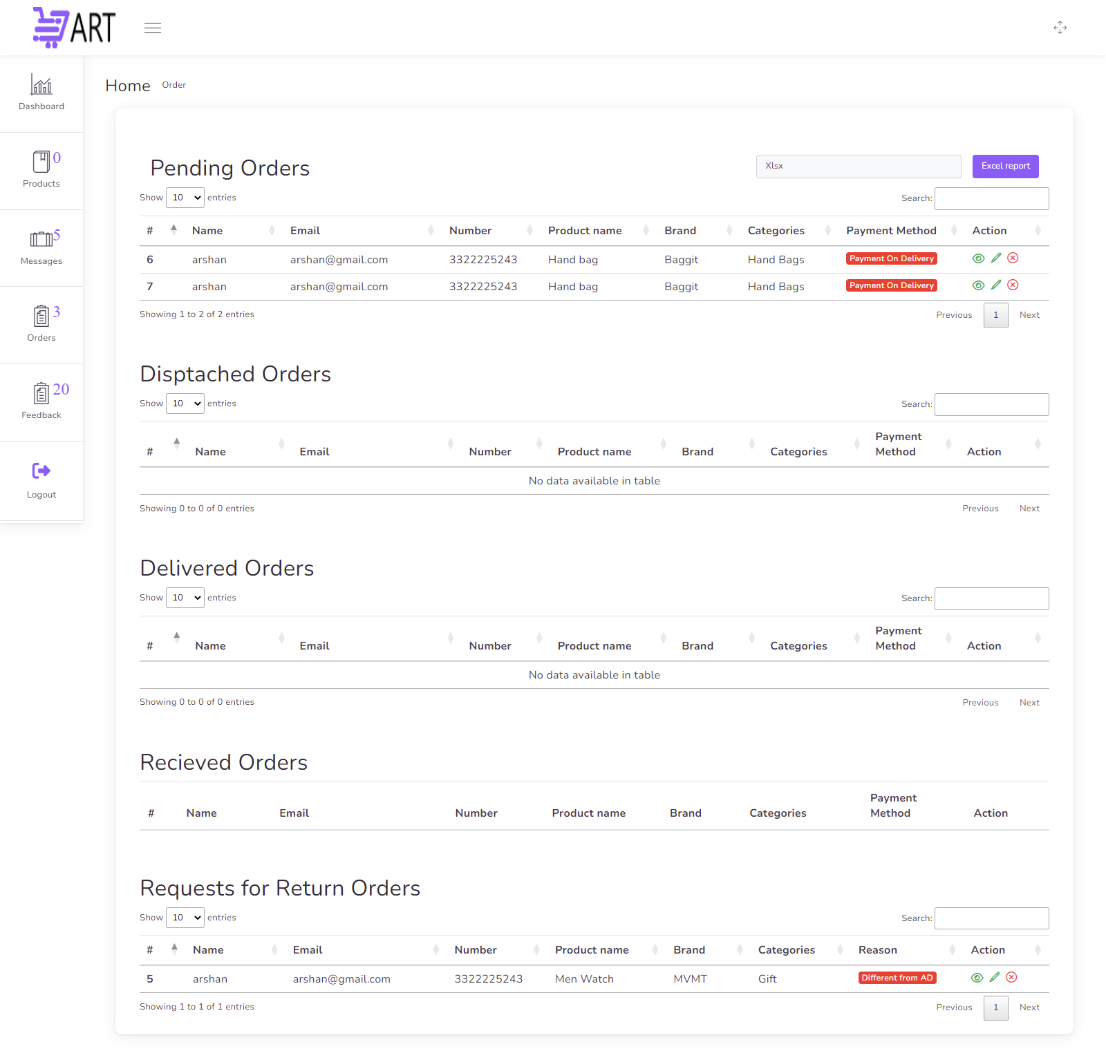

eProject: : Arts

52

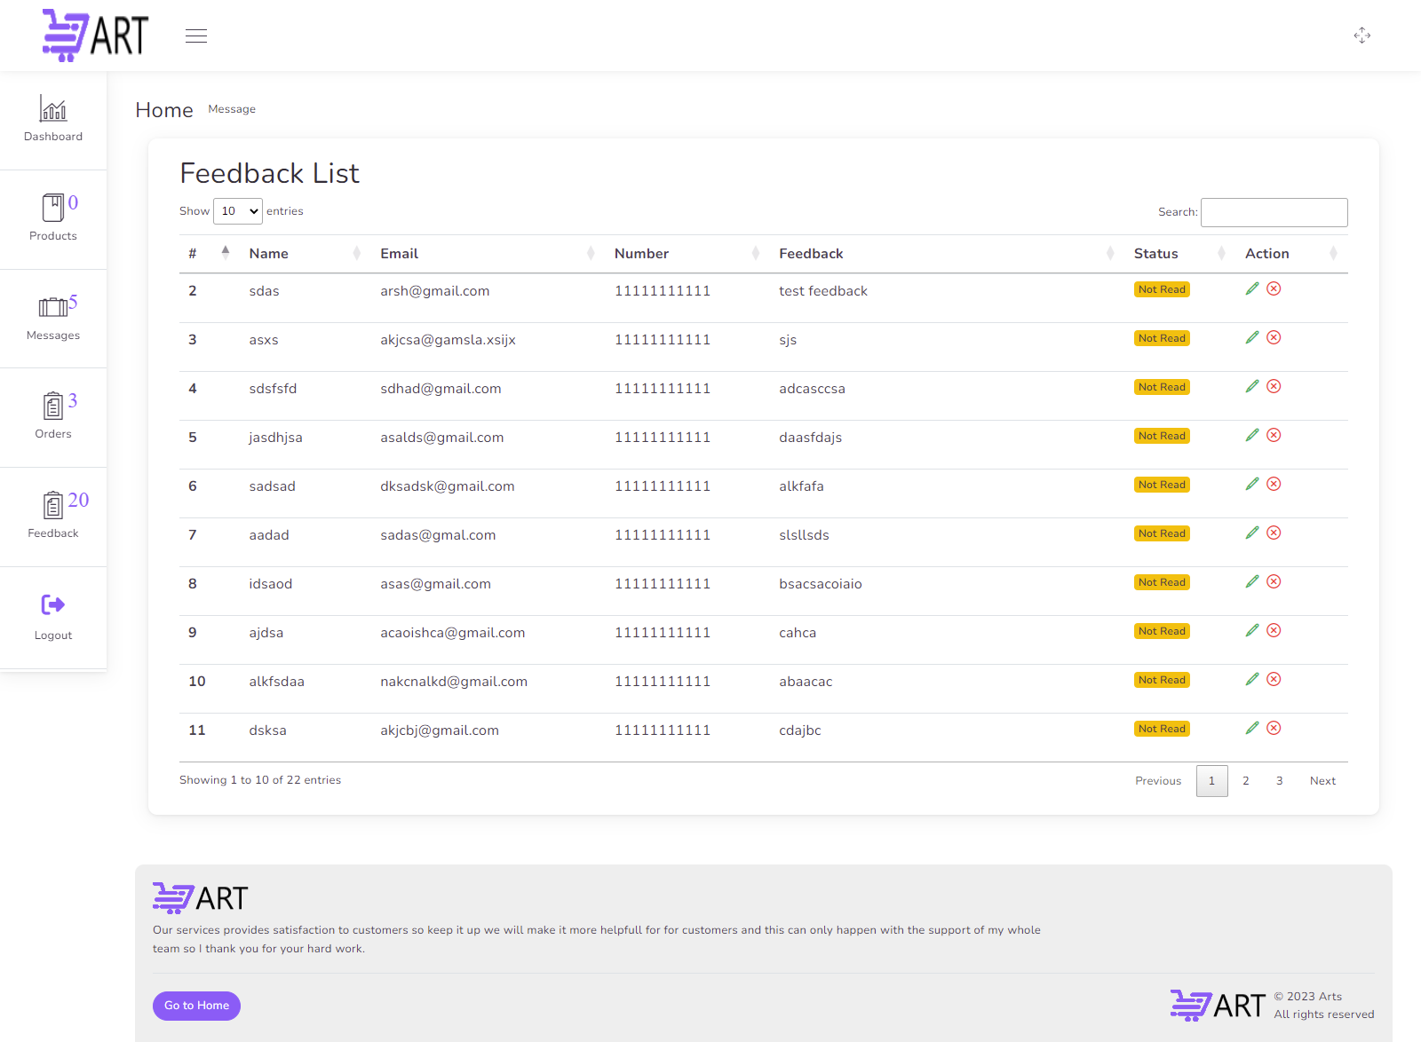

eProject: : Arts

53











eProject: : Arts

56





eProject: : Arts

57



DEVELOPER GUIDE

Technologies :

PHP Version[8.1.10]

MYSQL (Query Language)

HTML 5

CSS 3

JAVASCRIPT

JQUERY

BOOTSTRAP Version[5.1]

JQUERY DATA TABLE

WORK SHEETS (php spreadsheet documentation)

Templates :

Suruchi (For main interface Or for front hand)

For Further Information Check out the official site

https://themeforest.net/item/suruchi-fashion-ecommerce-html-template/36203669

Gulp (For Dashboard Or for back hand)

For Further Information Check out the official site

<https://themeforest.net/item/gull-bootstrap-laravel-admin-dashboard-template/23101970>

Guide :

To use this project, you must first place this folder in the c:xampp folder.and there is an htdocs

folder in the xampp folder; place this folder in this htdocs folder.

This site requires XAMPP to be installed on your device. Open Apache and MySQL there

This project includes a database folder which include database file oscart.sql; import this file

into your database management software.

Admin Credential :

Email : [arshan@gmail.com](mailto:arshan@gmail.com) AND Password : 098098

eProject: : Arts

62

PHP CODE

Here’s the Database Connection code and some SESSION Variables that i have written for this

site

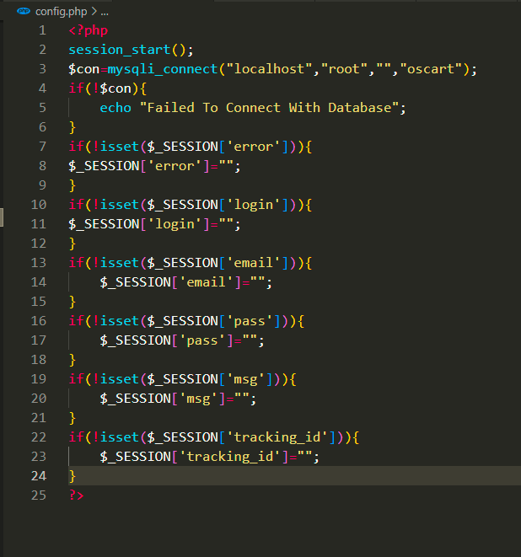

eProject: : Arts

61

PHP CODE

Here’s the signup code that i have written for this site

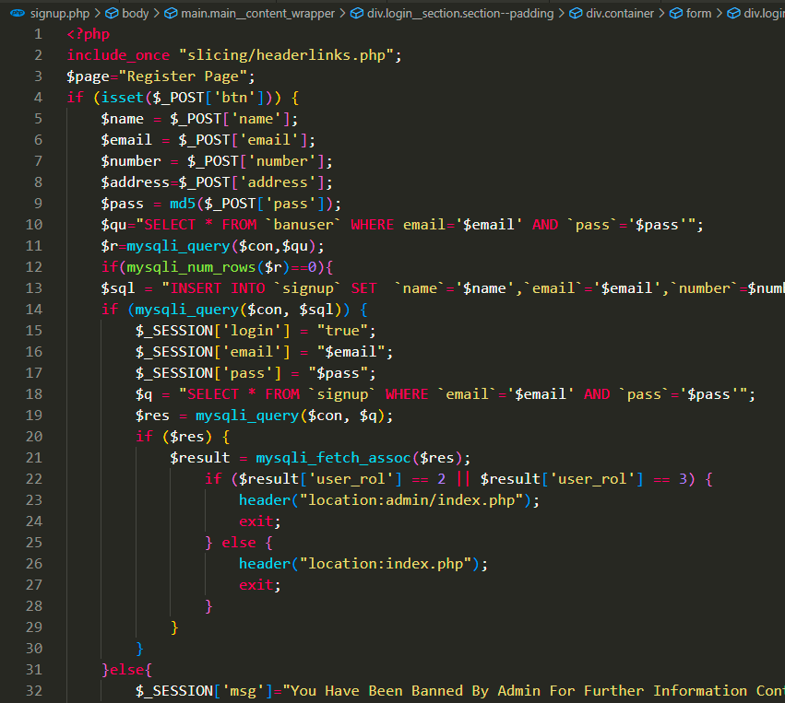

eProject: : Arts

62

PHP CODE

Here’s the Login code that i have written for this site

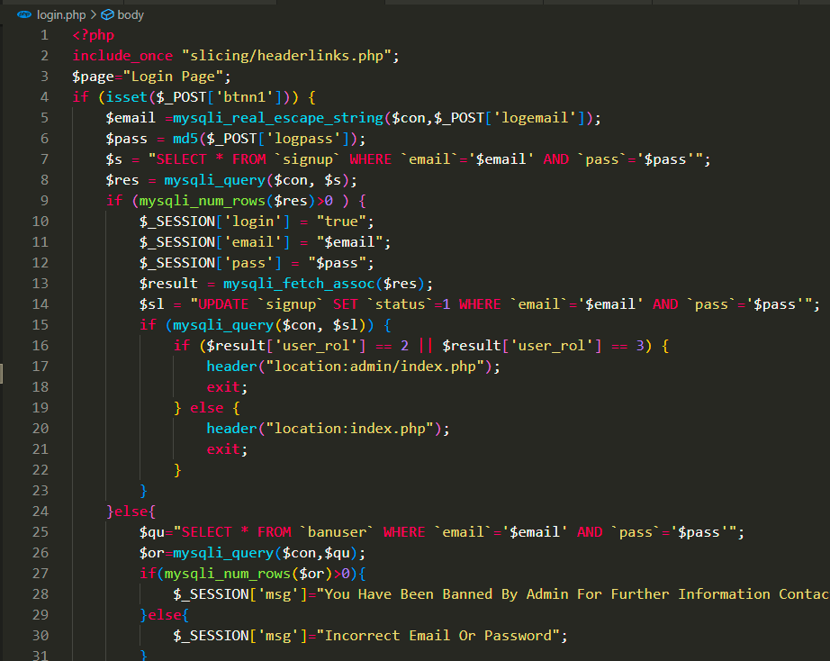

eProject: : Arts

63

PHP CODE

Here’s the Forgot code that i have written for this site

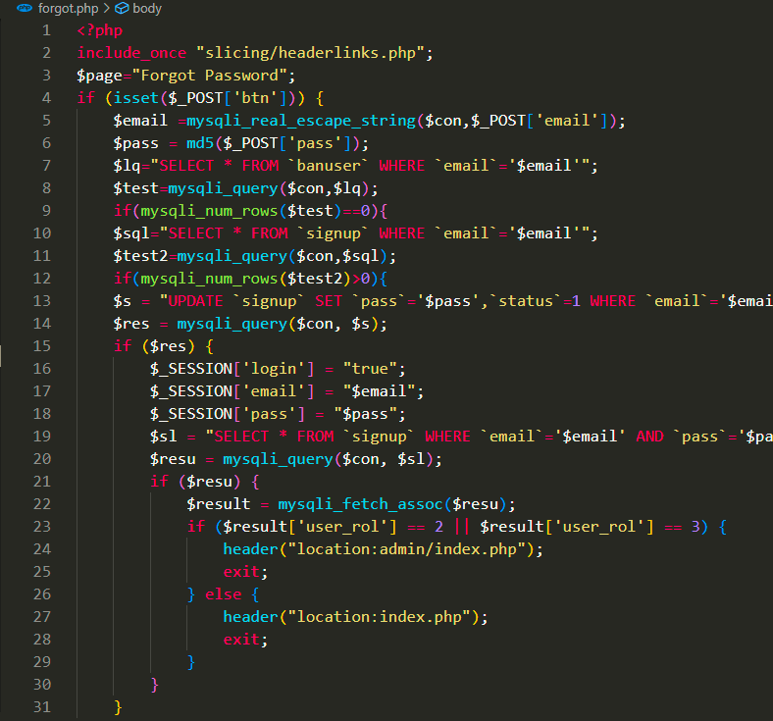

eProject: : Arts

64

PHP CODE

Here’s the Add To Wish List code that i have written for this site

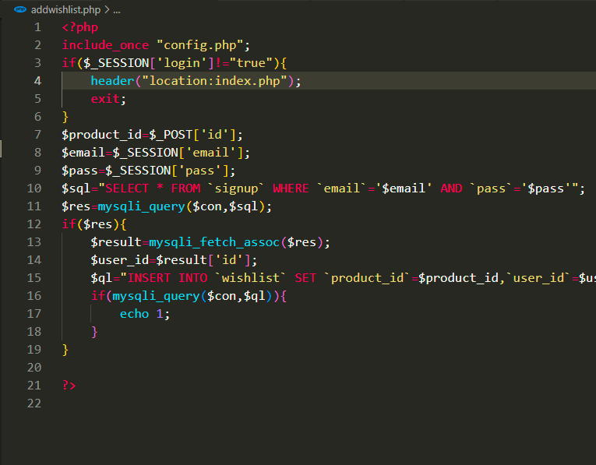

eProject: : Arts

65

PHP CODE

Here’s the Add To Cart code that i have written for this site

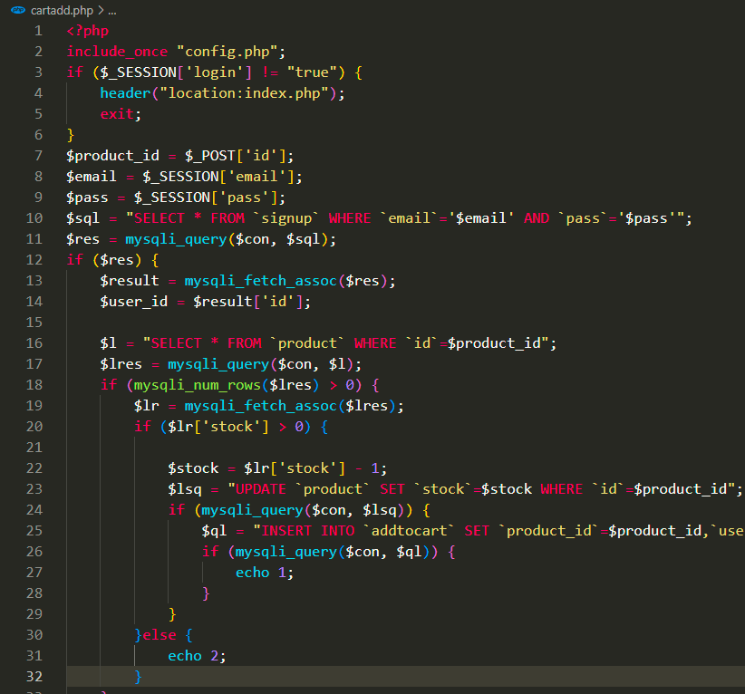

eProject: : Arts

66

PHP CODE

Here’s the Add To Cart And WishList Ajax code that i have written for this site

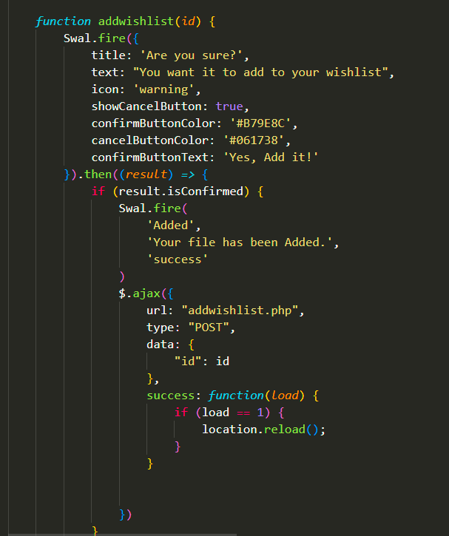

eProject: : Arts

67

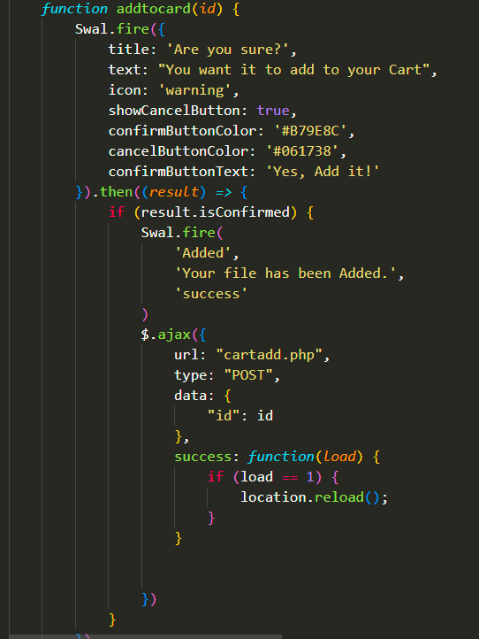

eProject: : Arts

68

PHP CODE

Here’s the Order code that i have written for this site

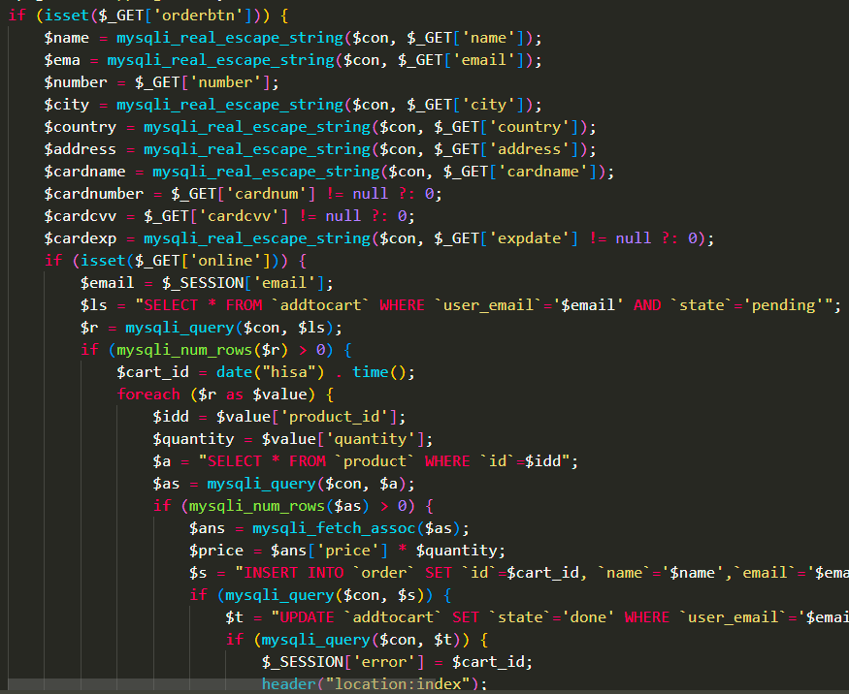

eProject: : Arts

69

PHP CODE

Here’s the Remaining Order code that i have written for this site

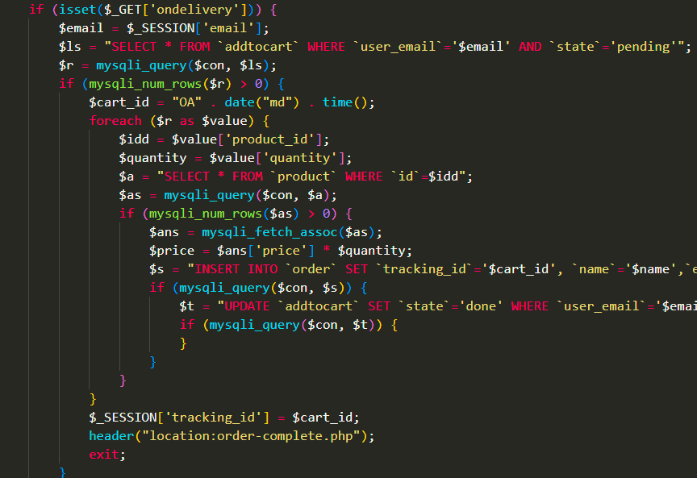

eProject: : Arts

70

PHP CODE

Here’s the Search code that i have written for this site

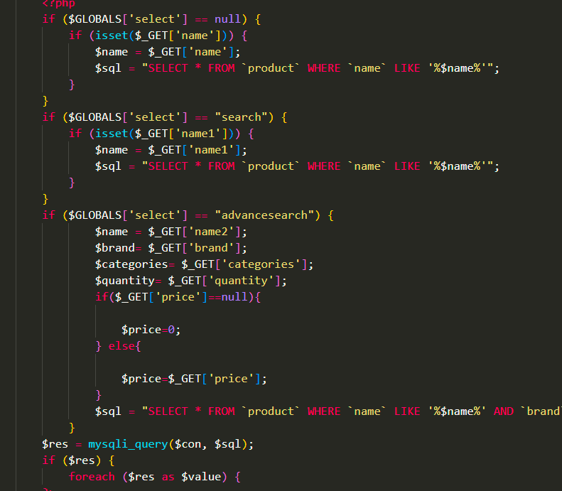

eProject: : Arts

71

PHP CODE

Here’s the Contact And Feedback code that i have written for this site

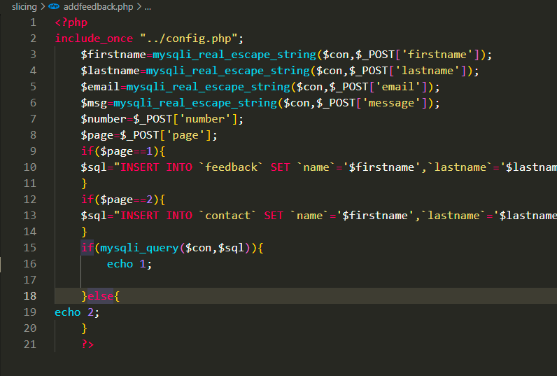

eProject: : Arts

72

PHP CODE

Here’s the Delete From Wishlist code that i have written for this site

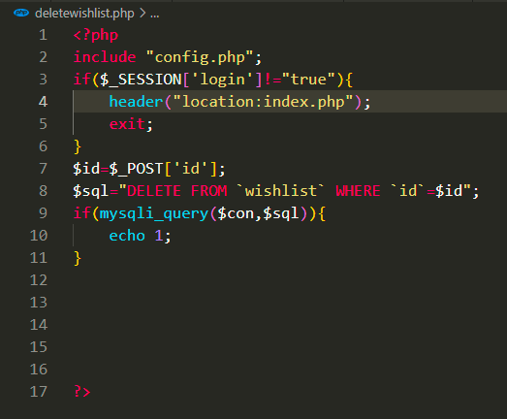

eProject: : Arts

73

PHP CODE

Here’s the Delete From Cart code that i have written for this site

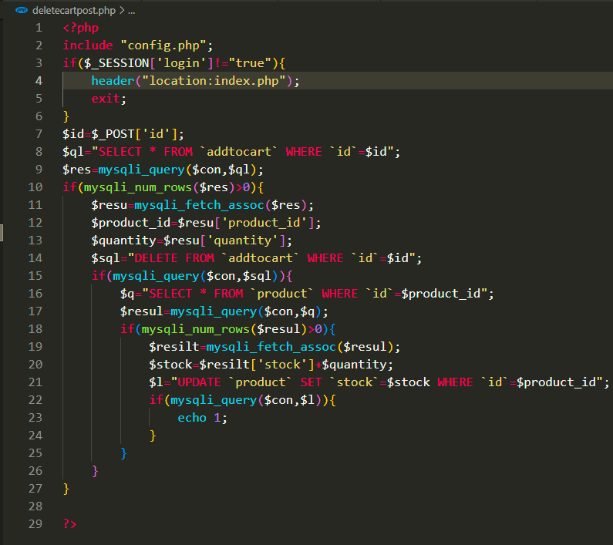

eProject: : Arts

74

PHP CODE

Here’s the Delete from Cart And WishList Ajax code that i have written for this site

Can find them both on wishlist.php and cart.php

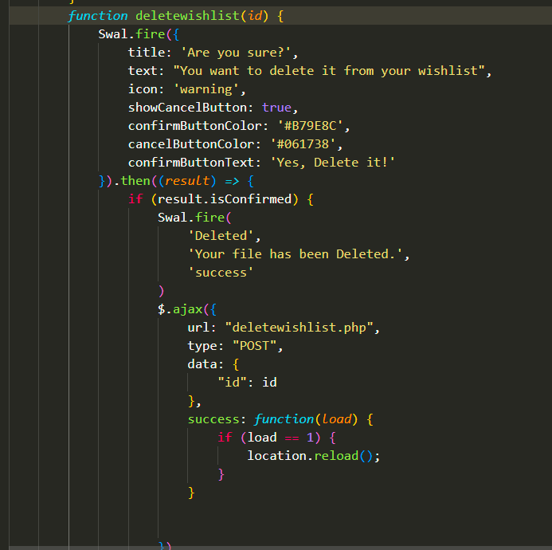

eProject: : Arts

75

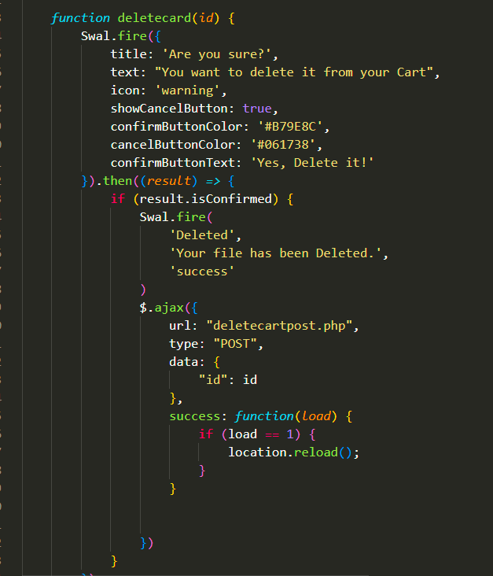

eProject: : Arts

76

PHP CODE

Here’s the Update Quantities From Cart code that i have written for this site

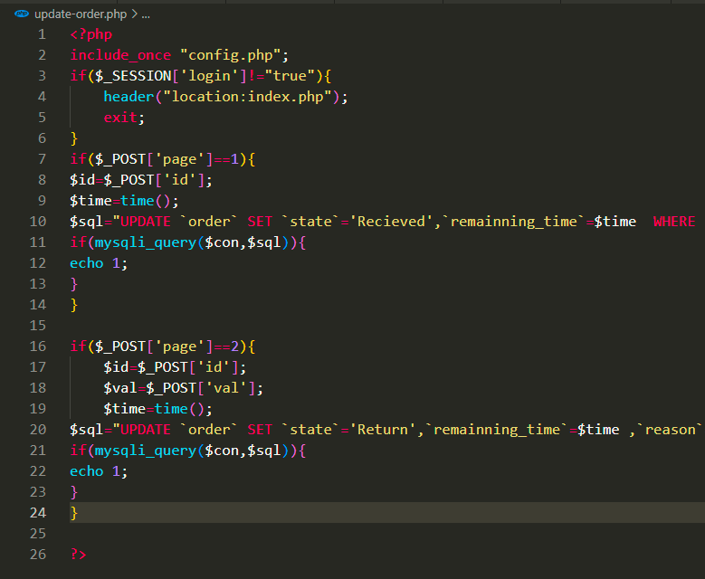

eProject: : Arts

77

PHP CODE

Here’s the Authentication code that i have written for this site

Login Authentication

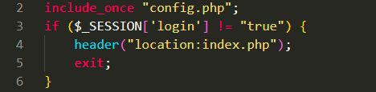

Role Authentication

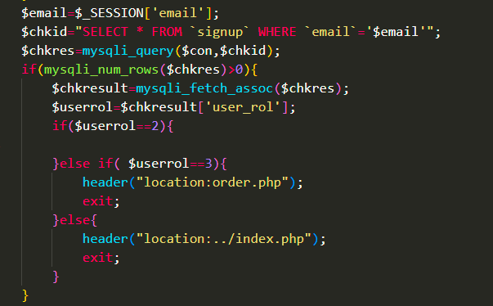

eProject: : Arts

78